**PROJECT REPORT**

**ON**

**URBAN MICRO-CELL SINR MAPPING : A 5G TEST ENVIRONMENT ANALYSIS**

*to be submitted by*

**KIRAN YADAV (2016410)**

*Under the supervision of*

**DR. SHUVABRATA BANDOPADHYAY**

Associated Professor

School of Physical Sciences

Banasthali Vidyapith



*For the award of the degree*

*Of*

**B.Tech (Electronics & Communication )**



**DEPARTMENT OF ELECTRONICS**

**BANASTHALI VIDYAPITH**

**BANASTHALI – 304022**

**JUNE – 2024**

**CERTIFICATE**

This is to certify that the Project Report entitled “URBAN MICRO-CELL SINR MAPPING : A 5G TEST ENVIRONMENT ANALYSIS**”**  is a bonafide record of independent work done by KIRAN YADAV (Roll No. 2016410) under my supervision and submitted to **Banasthali Vidyapith** in partial fulfillment for the award of the Degree of **Bachelor of  Technology in Electronics & Communication  .**

Date:                                                                                 Signature of Supervisor

**DECLARATION**

This project report is a presentation of our original work. Wherever contributions of others are involved, every effort is made to indicate this clearly, with due reference to the literature, and acknowledgement of collaborative research and discussions. The work was done under the guidance Of Dr. Shuvabrata Bandopadhyay at Associate Professor , School of Physical Sciences, Banasthali Vidyapith, Rajasthan , India - 304022.

Sincerely,

KIRAN YADAV

Electronics & Communication , 2024 Batch

Banasthali Vidyapith, Rajasthan – 304022, India

**Acknowledgment**

I am sincerely grateful to everyone who has supported us throughout our internship. This experience has been invaluable and I would like to extend my heartfelt thanks to those who have guided and assisted us during this period.

First and foremost, I would like to express our profound gratitude to BANASTHALI VIDYAPITH for providing us with the opportunity to undertake this internship. The exposure and insights gained here have been instrumental in enhancing our professional and personal growth.

I am deeply indebted to our supervisor, Dr. Shuvabrata Bandopadhyay, for their continuous support, mentorship, and encouragement. Their expert guidance and constructive feedback were crucial in shaping our learning experience and contributed significantly to the successful completion of my internship.

My appreciation also extends to all the team members at Banasthali Vidyapith. Their cooperation, friendly demeanor, and willingness to share their knowledge made our internship experience both educational and enjoyable.

I would like to thank BANASTHALI VIDYAPITH and Dr. Shuvabrata Bandopadhyay for their unwavering support and for facilitating this internship opportunity. Their advice and encouragement throughout our academic journey have been invaluable.

Finally, I am grateful to our family and friends for their constant encouragement and understanding during this period. Their support has been a source of strength and motivation for us.

**Sincerely,**

**KIRAN**

**Electronics & Communication, 2024 Batch**

Banasthali Vidyapith, Rajasthan , 304022, India

**Abstract**

This study presents a detailed methodology for constructing and visualizing Signal-to-Interference-plus-Noise Ratio (SINR) maps within a 5G urban macro-cell test environment, aligning with the guidelines outlined in Report ITU-R M.[IMT-2020.EVAL]. The focus is on the dense urban scenario characterized by high user density and substantial traffic loads, encompassing both pedestrian and vehicular users (Dense Urban-eMBB). The network layout comprises 19 cell sites arranged in a hexagonal pattern, with each site containing three sectors.

Using MATLAB® integrated with the Antenna Toolbox™ and Phased Array System Toolbox™, we established and configured the cell sites, defined cell parameters, and implemented custom antenna arrays. Initially, SINR maps were generated employing a single antenna element based on defined pattern parameters. Subsequently, we explored the implementation of an 8-by-8 uniform rectangular antenna array to enhance directional gain and SINR values. This array, designed with specific element spacing and tapering to minimize sidelobes, illustrated the potential of phased array principles.

Our analysis revealed that the rectangular antenna array offered superior directional gain, resulting in higher peak SINR values compared to a single antenna element. By utilizing the Close-In propagation model, which takes into account increased path loss typical in urban scenarios, SINR maps showed further improvement with reduced interference effects. Additionally, replacing equation-based antenna elements with half-wavelength rectangular microstrip patch antennas yielded comparable SINR performance, with minor differences in peak gain and pattern symmetry.

The findings underscore the critical importance of advanced antenna array configurations and realistic propagation models in optimizing SINR within dense urban 5G networks. The rectangular antenna array notably enhanced network performance by improving signal directionality and mitigating interference. This research provides a robust framework for the future design and evaluation of 5G networks, ensuring reliable and efficient communication in urban macro-cell environments.

Furthermore, the study emphasizes the significance of accurate SINR visualization for comprehending the performance and limitations of 5G networks. By comparing various antenna configurations and propagation models, we deliver a detailed assessment of their impact on network coverage and quality. This approach not only aids in designing efficient 5G networks but also serves as a crucial tool for ongoing optimization as technology and user demands continue to evolve.

By meticulously constructing a 5G urban macro-cell test environment and visualizing SINR maps, this study offers valuable insights into the deployment and optimization of 5G networks. It highlights the essential role of sophisticated antenna designs and propagation modeling in achieving high performance and reliability in next-generation wireless communication systems. This work lays a foundational groundwork for future advancements in 5G technology, ensuring robust and scalable network solutions capable of meeting the growing demands of urban environments.

Our study advances the performance of 5G networks in urban settings by integrating realistic antenna models and advanced simulation techniques. It serves as a foundational reference for engineers and researchers, with future work focusing on the dynamic adaptation of antenna arrays and real-time SINR monitoring. This comprehensive approach ensures that 5G networks can be continuously optimized and adapted to meet the evolving challenges and requirements of urban environments, facilitating seamless and efficient wireless communication for all users

**List Of Figures**

| Figures No. | Figures Description | Page No. |
| --- | --- | --- |

1. Network Coverage 23

2. Network Layout 24

3. Free Space propagation loss 25

different operating freqs.

4. RF signal attenuation due to 31

Rainfall for different operating freqs.

5. RF signal attenuation due to fog for 32

different operating freqs.

6. Antenna Element 43

7. SINR Map for Single Antenna Element44

8 . Create 8-by-8 Rectangular Antenna Array 44

9. SINR Map for 8-by-8 Antenna Array 45

10. SINR Map Using Close-In Propagation Model 46

11. Use Rectangular Patch Antenna as Array Element 47

12. SINR Map Using the Patch Antenna Element in the 8-by-8 Array 48

13. SINR Heatmap of Glasgow, Scotland 49

**Acronyms**

SINR - Signal-to-Interference-plus-Noise Ratio

ITU-R - International Telecommunication Union Radio communication Sector

IMT-2020 - International Mobile Telecommunications system for 2020

eMBB - Enhanced Mobile Broadband

ISD - Inter-Site Distance

GHz - Gigahertz

URA - Uniform Rectangular Array

dB - Decibel

m - Meter

MHz - Megahertz

W - Watt

dBm - Decibel-mill watt

dBi - Decibels relative to isotropic radiator

ITU - International Telecommunication Union

IMT-Advanced - International Mobile Telecommunications - Advanced

IEEE - Institute of Electrical and Electronics Engineers

UTM: Universal Transverse Mercator

API: Application Programming Interface

GUI: Graphical User Interface

LOS: Line-of-Sight

FAQ: Frequently Asked Questions

FFT: Fast Fourier Transform

**Abstract**

This study presents a detailed methodology for constructing and visualizing Signal-to-Interference-plus-Noise Ratio (SINR) maps within a 5G urban macro-cell test environment, aligning with the guidelines outlined in Report ITU-R M.[IMT-2020.EVAL]. The focus is on the dense urban scenario characterized by high user density and substantial traffic loads, encompassing both pedestrian and vehicular users (Dense Urban-eMBB). The network layout comprises 19 cell sites arranged in a hexagonal pattern, with each site containing three sectors.

Using MATLAB® integrated with the Antenna Toolbox™ and Phased Array System Toolbox™, we established and configured the cell sites, defined cell parameters, and implemented custom antenna arrays. Initially, SINR maps were generated employing a single antenna element based on defined pattern parameters. Subsequently, we explored the implementation of an 8-by-8 uniform rectangular antenna array to enhance directional gain and SINR values. This array, designed with specific element spacing and tapering to minimize sidelobes, illustrated the potential of phased array principles.

Our analysis revealed that the rectangular antenna array offered superior directional gain, resulting in higher peak SINR values compared to a single antenna element. By utilizing the Close-In propagation model, which takes into account increased path loss typical in urban scenarios, SINR maps showed further improvement with reduced interference effects. Additionally, replacing equation-based antenna elements with half-wavelength rectangular microstrip patch antennas yielded comparable SINR performance, with minor differences in peak gain and pattern symmetry.

The findings underscore the critical importance of advanced antenna array configurations and realistic propagation models in optimizing SINR within dense urban 5G networks. The rectangular antenna array notably enhanced network performance by improving signal directionality and mitigating interference. This research provides a robust framework for the future design and evaluation of 5G networks, ensuring reliable and efficient communication in urban macro-cell environments.

Furthermore, the study emphasizes the significance of accurate SINR visualization for comprehending the performance and limitations of 5G networks. By comparing various antenna configurations and propagation models, we deliver a detailed assessment of their impact on network coverage and quality. This approach not only aids in designing efficient 5G networks but also serves as a crucial tool for ongoing optimization as technology and user demands continue to evolve.

By meticulously constructing a 5G urban macro-cell test environment and visualizing SINR maps, this study offers valuable insights into the deployment and optimization of 5G networks. It highlights the essential role of sophisticated antenna designs and propagation modeling in achieving high performance and reliability in next-generation wireless communication systems. This work lays a foundational groundwork for future advancements in 5G technology, ensuring robust and scalable network solutions capable of meeting the growing demands of urban environments.

Our study advances the performance of 5G networks in urban settings by integrating realistic antenna models and advanced simulation techniques. It serves as a foundational reference for engineers and researchers, with future work focusing on the dynamic adaptation of antenna arrays and real-time SINR

**Table of Content**

**CHAPTER 1: INTRODUCTION……………………………………………….**

1.1 General

1.2 Objective

**CHAPTER 2: LITERATURE REVIEW……………………………………….**

2.1 5G Network Coverage Planning

2.2 Understeunding Network Coverage

2.3 Network layout

2.4 Cell Parameters

2.5 Transmitter site creation

2.6 Antenna Array Design

2.7 SINR Map Visualization for Signal Antenna Element

2.8 Propagation Modelling

2.9 RF Link Budget Analysis

2.10 Patch Antenna Element Integration

**CHAPTER 3: METHODOLOGY……………………………………………………**

3.1 Define Network Layout

3.2 Define Cell Parameter

3.3 Create Transmitter Sites

3.4 Create Antenna Element

3.5 Display SINR Map for Single Antenna Element

3.6 Create 8-by-8 Rectangular Antenna Array

3.7 Display SINR map for 8-by- & Antenna Array

3.8 Display SINR map using close in propagation model

3.9 Use Rectangular Patch Antenna as Array Element

**CHAPTER 4: RESULTS AND DISCUSSION……………………………………………**

**CHAPTER 5: SUMMARY AND CONCLUSION……………….………….……………**

5.1 Summary

5.2 Conclusion

5.3 Future work

**CHAPTER 6: Appendix …………………………………………………………………**

**CHAPTER 7: REFERENCES……………………………………………………………**

**Chapter 1**

**INTRODUCTION**

**1.1 General**

5G is the newest superpower in wireless technology. It is a huge step forward that’s changing how we communicate. With promises of unprecedented speed, reliability, and connectivity, 5G embodies a paradigm shift in how we interact with technology.

In the rapidly evolving landscape of wireless communication, the transition from 4G to 5G marks a significant leap forward, promising unprecedented speed, capacity, and connectivity. The superiority of 5G over 4G LTE is evident across multiple dimensions, including speed, latency, capacity, flexibility, and energy efficiency. While 4G revolutionized mobile communication by enabling faster data rates and enhanced multimedia experiences, 5G aims to redefine the very fabric of connectivity by offering ultra-fast speeds, ultra- low latency, and massive device connectivity.

* **Increased Data Rate** **:** While 4G LTE offers impressive download speeds averaging around 20-30 Mbps and peak speeds up to 100 Mbps, with 5G, users can expect peak download speeds exceeding 1 Gbps and potentially reaching up to 10 Gbps or higher.
* **Reduced Latency :** 4G LTE typically offers latency in the range of 30 to 50 milliseconds. Whereas 5G aims to reduce this latency to as low as 1 millisecond or less. This ultra-low latency is a game-changer for real-time applications such as online gaming, video conferencing, and autonomous vehicles.
* **Greater Capacity :** 5G networks are designed to support a much larger number of connected devices and simultaneous users within a given area compared to 4G networks. While 4G LTE supports around 1,000 connected devices per square kilometer, 5G aims to support up to 1 million connected devices per square kilometer.
* **Network Architecture :** 4G LTE networks are based on the Evolved Packet Core (EPC) architecture, which is primarily designed for data-centric services. 5G networks introduce a new architecture called the 5G Core (5GC), which is more flexible and scalable, enabling network slicing, edge computing, and service-based architecture (SBA) for efficient resource allocation and service delivery.
* **Support Use Cases :**  Another key distinguishing features of 5G is its flexibility and support for a wide range of use cases beyond traditional mobile broadband. While 4G LTE primarily focused on delivering high-speed internet access to consumers, 5G is designed to cater to diverse applications and industries, including enhanced mobile broadband (eMBB), massive machine-type communications (mMTC), and ultra-reliable low latency communications (URLLC).

By minimizing energy consumption and reducing environmental impact, 5G aims to strike a balance between performance and sustainability, ensuring that the benefits of connectivity are accessible to all while minimizing the carbon footprint of wireless networks. [1]

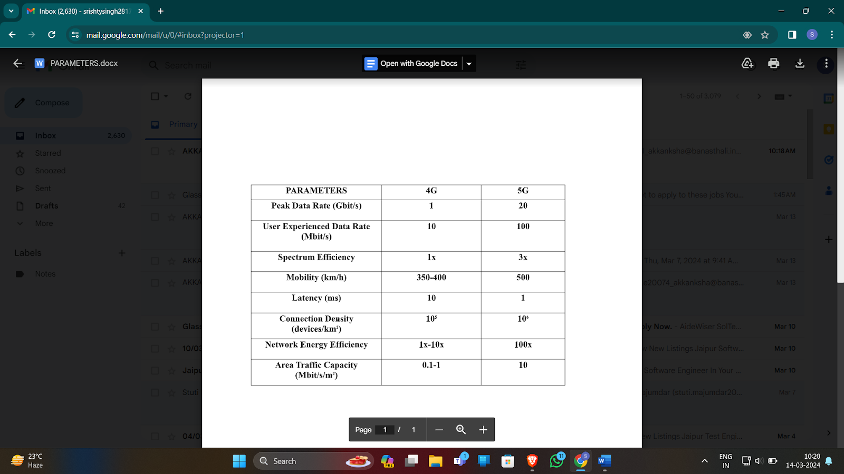

Within the context of **IMT-Advanced (IMT-A) and IMT-2020** specifications, it reveals a substantial leap in performance and capability. Initially, IMT-A, represented by 4G LTE, aimed to provide peak data rates of up to 1 Gbps for stationary users and 100 Mbps for mobile users. However, IMT-2020 specifications set ambitious targets, aiming for peak data rates of up to 20 Gbps for downlink and 10 Gbps for uplink, significantly surpassing the capabilities of its predecessor. Furthermore, while IMT-A specified latency of up to 10 milliseconds (ms) for user plane and up to 100 ms for control plane communications, IMT-2020 targeted ultra-low latency of 1 ms or less. These enhancements translate into increased capacity, allowing 5G networks to better support a wide range of applications, from enhanced mobile broadband to massive machine-type communications and ultra-reliable low-latency communications. Moreover, the technological advancements incorporated into 5G NR specifications, such as network slicing and edge computing, further elevate the performance, reliability, and flexibility of 5G networks compared to 4G LTE. In essence, 5G technology under IMT- 2020 specifications represents a significant advancement over its predecessor, offering superior data rates, lower latency, enhanced spectral efficiency, and increased capacity, thus catering to a broader range of use cases and driving innovation across industries.[2]

5G technology introduces a plethora of new and innovative use cases across various industries due to its high speed, low latency, massive connectivity, and reliability. Some of the key use cases of 5G are :

1. **Enhanced Mobile Broadband (eMBB) :** With eMBB, users can expect to enjoy lag-free, high-quality multimedia experiences anytime, anywhere, ushering in a new era of mobile entertainment and productivity. eMBB enables higher data rates and enhanced capacity compared to previous generations of mobile networks. It supports applications like high-definition video streaming, virtual reality, augmented reality, and ultra-high-definition gaming. eMBB is focused on delivering faster and more reliable broadband services to mobile users.

* **High Capacity and Throughput :** 5G offers peak download speeds of up to multi-gigabits per second (Gbps), which is several times faster than 4G LTE.
* **Improved Coverage and Connectivity :** 5G networks can support up to 100 times more connected devices per unit area compared to 4G LTE.
* **Latency Requirement :** Latency targets for eMBB applications in 5G networks are typically in the range of 10-20 milliseconds (ms).

1. **Massive Machine Type Communications (mMTC) :** From interconnected urban infrastructure to remote industrial assets, mMTC enables seamless communication and data exchange among diverse IoT devices, driving efficiency, sustainability, and innovation across industries. mMTC optimizes network resources to efficiently handle the massive scale of connected devices while consuming minimal power.

* **Number of Connected Devices :** 5G networks can support up to 1 million connected devices per square kilometer, enabling massive IoT deployments.
* **Latency Requirement :** Latency targets for mMTC applications in 5G networks are typically in the range of 1-10 milliseconds (ms).
* **Intermittent Communication:** Unlike traditional communication methods, MMTC doesn't require constant data transmission. Instead, it supports intermittent or sporadic communication between devices. This means devices can send data only when needed, conserving energy and network resources.[3]

1. **Ultra-Reliable Low-Latency Communications (URLLC) :** With ultra-low latency and unparalleled reliability, URLLC empowers real-time decision-making, fosters safety and precision, and unlocks the full potential of transformative technologies in the digital age.

* **Latency Requirement :** URLLC applications require end-to-end latency of less than 1 millisecond (ms) in 5G networks.
* **Reliability :** 5G networks target reliability levels of over 99.999%, making them suitable for mission-critical use cases such as autonomous vehicles and industrial automation.
* **Public Safety and Emergency Services :** URLLC enhances public safety and emergency response capabilities by enabling fast and reliable communication among first responders and emergency personnel.

In conclusion, 5G emerges as a transformative force reshaping the contours of connectivity and innovation across industries. With its pillars of eMBB, mMTC, and URLLC, 5G promises to unleash a wave of unparalleled experiences, applications, and opportunities, fuelling a new era of digital.

The latest standard in wireless communication networks developed by the 3rd Generation Partnership Project (3GPP) is represented by 5G NR, or 5G New Radio. 5G NR serves as the cornerstone of the 5G wireless communication standard. It is operated across a wide range of frequency bands, including sub-6 GHz and mmWave bands and supports peak data rates of up to 20 Gbps in the downlink (DL) and 10 Gbps in the uplink (UL). Spectral efficiency in 5G NR can be up to 3 times higher than that of 4G LTE. It incorporates Massive MIMO technology, enabling the use of a large number of antennas at both the transmitter and receiver. Furthermore, 5G NR introduces the concept of network slicing, allowing operators to partition a single physical network infrastructure into multiple virtual networks. Operating across two primary frequency bands, 5G NR provides versatility and flexibility to address diverse deployment scenarios and use cases. Key technologies such as Massive Multiple Input Multiple Output (MIMO) and beamforming enhance the efficiency and performance of 5G NR networks. Massive MIMO utilizes multiple antennas to transmit and receive data simultaneously, increasing network capacity and spectral efficiency. Beamforming enables directed signal transmission towards specific users or devices, optimizing coverage and mitigating interference, particularly in mm Wave deployments. Each slice can be tailored to meet the specific requirements of different applications and industries, ensuring efficient resource allocation and quality of service.[4]

In essence, 5G NR represents a monumental leap forward in wireless technology, unlocking new possibilities and opportunities across industries and sectors. With its unprecedented speed, capacity, and capabilities, 5G NR is poised to redefine connectivity and revolutionize the way we live, work, and interact in the digital age. 5G-NR operates in two main frequency bands: Frequency Range 1 (FR1) and Frequency Range 2 (FR2), each with its unique characteristics and applications

.

* **Frequency Range 1 (FR1):** FR1 encompasses sub-6 GHz frequency bands and serves as the primary spectrum for 5G deployments worldwide. It includes frequencies traditionally used by 4G LTE networks as well as newly allocated spectrum. FR1 offers excellent coverage and penetration characteristics, making it suitable for widespread deployment in urban, suburban, and rural areas. Within FR1, several frequency bands are allocated, including but not limited to 600 MHz**,** 700 MHz**,** 2.5 GHz**,** 3.5 GHz**,** and 4.9 GHz**.** These frequency bands offer a balance between coverage, capacity, and data rates, enabling operators to deliver enhanced mobile broadband (eMBB) services, support massive machine-type communications (mMTC), and provide reliable low-latency communications (URLLC) across diverse use cases and environments.
* **Frequency Range 2 (FR2):** FR2, also known as mm Wave (millimetre-wave) spectrum, operates in the frequency range above 24 GHz, including bands such as 28 GHz and 39 GHz. FR2 offers significantly wider bandwidths compared to FR1, enabling ultra-high data rates and low latency. However, mm Wave signals are susceptible to attenuation and limited in coverage range, making them suitable for dense urban environments and specific use cases such as fixed wireless access, high-capacity hotspots, and augmented reality applications.

In summary, 5G-NR, and its frequency bands, FR1 and FR2, represent a diverse spectrum landscape catering to a wide range of applications and deployment scenarios. While FR1 provides broad coverage and versatile capabilities, FR2 unlocks the potential for ultra-high-speed, low-latency communications in dense urban areas and high-demand environments, collectively shaping the future of 5G connectivity and innovation.

In 5G networks, the signal flow for both the control plane and user plane follows a structured path, but they serve distinct functions in managing network operations and facilitating data transmission, respectively. For the **control plane**, the signal flow involves the establishment, maintenance, and termination of connections between user devices and the network. It begins with the initial connection setup, where the user device sends a request to the network, typically through a signalling message such as a Radio Resource Control (RRC) message. This request is received by the Radio Access Network (RAN), which forwards it to the Core Network (CN) for processing. The CN then initiates authentication and authorization procedures, verifies the user's identity, and assigns resources for the connection. Once authenticated, the CN establishes a context for the user session, allocating network resources and setting signalling paths for subsequent communication. Throughout the session, the control plane manages the connection, handling mobility events such as handovers between base stations or mobility between different access technologies (e.g., 5G to Wi-Fi). This involves exchanging signalling messages between the RAN and CN to maintain seamless connectivity as the user moves. Finally, when the user session concludes or is terminated, the control plane releases allocated resources, updates network databases, and sends signalling messages to notify the network of the session termination.

In contrast, the **user plane** signal flow is responsible for transmitting data packets between user devices and network services. Once the control plane has established a connection, the user plane handles the actual data transmission. User data packets originating from applications or services on the user device are encapsulated and transmitted over the established connection through the RAN and Core Network. In the RAN, data packets are processed by the Radio Link Control (RLC) and Medium Access Control (MAC) layers before being transmitted over the air interface to the base station. From there, the packets are forwarded through the Core Network, where they undergo routing, forwarding, and other network functions before reaching their destination. Throughout the user plane signal flow, data packets may traverse multiple network nodes and undergo various processing tasks such as encryption, compression, and Quality of Service (QoS) management. Ultimately, the goal of the user plane is to deliver data packets reliably and efficiently between user devices and network services, ensuring a seamless and responsive user experience for applications such as video streaming, web browsing, and online gaming. In summary, while both the control plane and user plane signal flows are essential components of 5G network architecture, they serve distinct purposes in managing connections and facilitating data transmission. The control plane manages session establishment, mobility management, and resource allocation, while the user plane handles the actual transmission of data packets between user devices and network services. Together, these signal flows enable 5G networks to deliver high-performance, low-latency connectivity for a wide range of applications and services.

The protocol stack of 5G NR (New Radio) consists of multiple layers, each serving distinct functions in both the control plane and the user plane. Here's an overview of the protocol stack along with the functions of each layer for both planes:

**Protocol Stack of 5G NR:**

1. **Physical Layer (PHY) Layer:** It handles essential tasks such as signal modulation, channel coding, and data stream multiplexing. These functions optimize signal efficiency, ensure error detection and correction, and enable simultaneous data transmission. The Physical Layer forms the foundation of 5G communication, supporting reliable wireless connectivity. These fundamental operations form the backbone of the Physical Layer, laying the groundwork for seamless and reliable wireless communication in the 5G ecosystem.

* **Control Plan**e**:** The PHY layer manages the transmission and reception of physical signals over the air interface. It employs modulation techniques to encode digital data into analog signals for transmission and decode received signals back into digital data. Additionally, the PHY layer handles tasks such as channel estimation, synchronization, and error correction coding to ensure reliable communication.
* **User Plane:** The PHY layer in the user plane is responsible for converting digital data into analog signals for transmission over the air interface and vice versa. It employs advanced modulation and coding schemes to maximize data throughput and spectral efficiency. In 5G, the PHY layer supports multiple numerologies and waveform formats to accommodate diverse use cases and deployment scenarios.

1. **Medium Access Control (MAC) Layer:** The MAC Layer in the 5G NR protocol stack, positioned at Layer 2, handles crucial tasks for efficient communication. It manages resource allocation, transmission scheduling, random access, and power control. By optimizing resource usage and regulating data flow, it ensures smooth network operation. It facilitates seamless device connections and enhances energy efficiency, making it indispensable for 5G communication. In essence, the MAC Layer serves as a cornerstone of 5G communication, facilitating the efficient and reliable exchange of data between devices and the network infrastructure**.**

* **Control Plan**e**:** The MAC layer is responsible for coordinating access to the shared radio resources among multiple users. It performs functions such as scheduling, prioritization, and resource allocation to optimize the utilization of the available spectrum. The MAC layer also implements mechanisms like HARQ (Hybrid Automatic Repeat Request) for error recovery and retransmissions.
* **User Plane:** The MAC layer manages access to the radio resources in the user plane. It coordinates the transmission and reception of data packets between user equipment (UE) and the network infrastructure. The MAC layer implements scheduling algorithms to allocate resources efficiently, prioritize traffic based on Quality of Service (QoS) requirements, and support multi-user and multi-antenna communication techniques.

1. **Radio Link Control (RLC) Layer:** It manages data transmission over the radio link. Its key functions include segmenting and reassembling data units, error correction, and flow control. By breaking down data into manageable segments, correcting errors, and regulating data flow, the RLC Layer ensures efficient and reliable data transmission in the 5G network.

* **Control Plan**e**:** The RLC layer ensures the reliable and in-sequence delivery of data units between the transmitting and receiving ends of a communication link. It handles tasks such as segmentation and reassembly of data packets, error correction through retransmissions, and flow control to manage the rate of data transfer based on the receiver's capacity**.**
* **User Plane:** The RLC layer ensures the reliable and in-sequence delivery of data packets between the UE and the network. It performs functions such as segmentation and reassembly of data units, error correction through Automatic Repeat reQuest (ARQ) mechanisms, and flow control to regulate the rate of data transmission based on the receiver's buffer status and available resources.

1. **Packet Data Convergence Protocol (PDCP) Layer:** This layer of the 5G NR protocol stack is critical for efficient and secure data transmission. It compresses headers, encrypts data, ensures integrity, and handles error correction. By reducing overhead, protecting data, and correcting errors, the PDCP Layer ensures reliable and secure communication in the 5G network.

* **Control Plan**e**:** The PDCP layer handles the convergence of packet data streams from higher-layer protocols, such as IP (Internet Protocol), onto the radio interface. It performs functions like header compression to reduce overhead, ciphering to enhance security, and decompression to restore the original data format. The PDCP layer also manages the transmission of control plane signalling messages.
* **User Plane:** This layer optimizes the transmission of IP packets over the radio interface. It achieves this through header compression, encryption, and integrity protection. The layer also handles packet segmentation and reassembly when necessary. Overall, the PDCP layer ensures efficient, secure, and reliable data transmission in the 5G network.

1. **SDAP (Service Data Adaptation Protocol) Layer**: This layer of the 5G NR protocol stack, plays a critical role in managing quality of service (QoS) flow control and tunnelling of user data. Its primary functions include regulating the flow of data to ensure optimal QoS for different applications and services. Additionally, the SDAP layer facilitates the tunnelling of user data, enabling efficient and secure transmission across the network**.**

* **Control Plan**e**:** It facilitates the mapping between QoS parameters and bearer characteristics. Bearer characteristics define the attributes of the communication channel, including its capacity, latency, and reliability. By mapping QoS parameters to specific bearer characteristics, the SDAP Layer ensuresthat data traffic is routed through the most suitable bearer to meet its QoS requirements effectively.
* **User Plane**: The SDAP layer adapts the user data streams based on the service requirements and QoS parameters. It categorizes data packets into different QoS flows, applies traffic shaping and policing mechanisms to enforce traffic management policies, and ensures that user applications receive the appropriate level of service based on their specific needs.

The 5G NR protocol stack for both the control plane and user plane consists of several layers, each with specific functions aimed at ensuring reliable and efficient communication. These layers work together to manage the transmission of data and control signalling, providing the foundation for the high-speed, low-latency, and reliable connectivity promised by 5G technology.

In 5G NR (New Radio), the communication between the UE (User Equipment) and the gNB (Next-Generation NodeB) is organized into different channels at various layers of the protocol stack. These channels serve specific purposes in transmitting control and user data between the UE and the network.[5]

1. **Logical Channels**

* **Broadcast Channel (BCCH):** BCCH is a downlink-only logical channel responsible for broadcasting system information necessary for initial cell search, synchronization, and cell selection by UEs. This includes essential parameters such as cell ID, cell configuration, system bandwidth, and other broadcast system information.
* **Paging Channel (PCCH):** PCCH is a downlink-only logical channel used to carry paging messages from the network to UEs. These messages alert the UE of incoming calls, SMS messages, or other paging messages, prompting the UE to wake up from idle mode and access the network.
* **Common Control Channel (CCCH):** CCCH is a bidirectional logical channel used for random access procedures and carrying common control information. It facilitates the transmission of initial access requests from UEs to the network and access grant messages from the network to UEs.
* **Dedicated Control Channel (DCCH):** DCCH is a bidirectional logical channel dedicated to specific UE connections. It carries signaling messages associated with radio resource control (RRC), including connection establishment, mobility management, handover procedures, and other dedicated control information.
* **Shared Data Channel (SDCCH):** SDCCH is a bidirectional logical channel used for the transmission of shared data and control information for multiple UEs. It is often utilized in scenarios such as group calls or multicast/broadcast services where multiple UEs need to receive the same data simultaneously.

1. **Transport Channels:**

* **Broadcast Channel (BCH):** BCH is a downlink-only transport channel used to broadcast system information from the gNB to UEs. It aids UEs in initial cell search, synchronization, and cell selection by providing essential parameters required for network access.
* **Paging Channel (PCH):** PCH is a downlink-only transport channel responsible for delivering paging messages from the gNB to UEs. These messages alert UEs of incoming calls, SMS messages, or other notifications, prompting the UE to wake up from idle mode and access the network.
* **Common Control Channel (CCCH):** CCCH in the transport layer carries common control information between the gNB and UEs. It facilitates random access procedures and carries initial access requests from UEs to the network and access grant messages from the network to UEs.
* **Dedicated Control Channel (DCCH):** DCCH in the transport layer carries dedicated control information associated with specific UE connections. It includes signaling messages related to radio resource control (RRC), connection establishment, mobility management, and other dedicated control functions.
* **Multicast Channel (MCH):** MCH is a downlink-only transport channel used for the transmission of multicast and broadcast services from the gNB to multiple UEs simultaneously. It allows multiple UEs to receive the same data efficiently over the air interface.

1. **Physical Channels:**

* **Physical Downlink Control Channel (PDCCH):** PDCCH is a downlink-only physical channel responsible for delivering control information to UEs. It carries scheduling assignments, resource allocations, HARQ feedback, and other control information related to downlink data transmission.
* **Physical Uplink Control Channel (PUCCH):** PUCCH is an uplink-only physical channel used for transmitting control information from UEs to the gNB. It carries acknowledgment signals, channel quality reports, scheduling requests, and other control information related to uplink data transmission.
* **Physical Downlink Shared Channel (PDSCH):** PDSCH is a downlink-only physical channel used for transmitting user data and control information from the gNB to UEs. It delivers downlink data packets and control information to UEs.
* **Physical Uplink Shared Channel (PUSCH):** PUSCH is an uplink-only physical channel used for transmitting user data and control information from UEs to the gNB. It carries uplink data packets and control information generated by UEs.

The mapping of logical, transport, and physical channels ensures the efficient flow of data and control information across different layers of the protocol stack. Logical channels are mapped onto corresponding transport channels, and transport channels are then mapped onto physical channels for transmission over the air interface. This mapping ensures that data and control signals are delivered reliably and efficiently between UEs and the gNB, supporting various services and applications in the 5G NR network.[5]

In 5G NR, the mapping of logical, transport, and physical channels is crucial for efficient communication between user equipment (UE) and base stations.

* Logical channels, including Broadcast, Paging, Common Control, Dedicated Control, and Shared Data Channels, serve distinct functions in transmitting system information, paging messages, and control signals tailored to specific UE connections.
* Logical channels are mapped onto corresponding transport channels at the transport layer:
* Broadcast Channel (BCCH) maps to the Broadcast Channel (BCH).
* Paging Channel (PCCH) corresponds to the Paging Channel (PCH).
* Common Control Channel (CCCH) and Dedicated Control Channel (DCCH) map to the Common Control Channel (CCCH) and Dedicated Control Channel (DCCH) at the transport layer, respectively.
* Multicast Channel (MCH) is mapped to appropriate physical channels for downlink transmission.
* Transport channels are allocated to physical channels for transmission over the air interface:
* Broadcast Channel (BCH) and Paging Channel (PCH) map to the Physical Broadcast Channel (PBCH) and Physical Paging Channel (PPCH), respectively.
* Common Control Channel (CCCH) and Dedicated Control Channel (DCCH) are mapped to the Physical Downlink Control Channel (PDCCH) and Physical Uplink Control Channel (PUCCH) for bidirectional control signaling.
* Multicast Channel (MCH) finds its place in appropriate physical channels for downlink transmission.
* This mapping framework optimizes resource utilization, enhances spectrum efficiency, and facilitates reliable transmission of data and control information across the 5G network, contributing to the promised high-speed, low-latency connectivity of next-generation wireless technology.[6]

**1.2 Objectives**

**1. Evaluation of Test Environment and Antenna Performance:**

The assessment of the 5G urban macro-cell test environment involves evaluating its effectiveness in replicating real-world scenarios. This includes analyzing the arrangement of cells, inter-site distance, and antenna configurations. Furthermore, a comparative analysis between single antenna elements and 8-by-8 arrays is conducted to gauge their performances in terms of directional gain, peak SINR, and interference mitigation.

**2. Analysis of SINR Distribution and Propagation Models:**

The SINR distribution within the test environment is thoroughly examined to understand the effectiveness of different antennas and propagation models. Variations in SINR across the area provide insights into network performance and coverage under various configurations. Additionally, the accuracy of propagation models, particularly free space and close-in models, is assessed, focusing on factors like path loss estimation and interference modeling.

**Chapter 2**

**Literature Review**

The transition from 4G to 5G wireless communication systems heralds a new era of connectivity characterized by unprecedented speed, capacity, and reliability. Unlike previous generations, 5G is not just an evolutionary step; it represents a revolutionary leap in telecommunications technology, promising to transform industries, empower consumers, and drive innovation across diverse sectors.

At its core, 5G is built upon a foundation of advanced radio access techniques, network architecture enhancements, and spectrum utilization strategies designed to meet the evolving needs of today's digital society. By leveraging technologies such as massive MIMO, beamforming, and millimeter-wave frequency bands, 5G networks can deliver multi-gigabit data rates, ultra-low latency, and massive connectivity, enabling a wide range of applications spanning from augmented reality and autonomous vehicles to industrial automation and remote healthcare.

One of the defining features of 5G is its ability to support a diverse set of use cases with varying requirements in terms of throughput, latency, reliability, and scalability. From enhanced mobile broadband (eMBB) applications that demand high-speed internet access to massive machine-type communications (mMTC) scenarios involving billions of IoT devices, 5G networks are designed to accommodate a wide spectrum of services and applications, thereby unlocking new opportunities for innovation and economic growth.

Urban environments, with their dense population centers, complex infrastructure, and dynamic usage patterns, present both challenges and opportunities for 5G deployment. On one hand, the high population density and demand for bandwidth-intensive services pose significant capacity and coverage challenges for traditional cellular networks. On the other hand, the presence of advanced infrastructure, such as fiber optic backbones and small cell deployments, provides a solid foundation for the rollout of 5G networks in urban areas.

In order to assess the performance and scalability of 5G networks in urban environments, it is essential to develop realistic test scenarios and evaluation methodologies. This is where the concept of urban macro-cell test environments comes into play. These test environments serve as controlled settings for evaluating the performance of 5G networks under real-world conditions, taking into account factors such as signal propagation, interference, mobility, and user density.

The project aims to construct and evaluate 5G urban macro-cell test environments based on the guidelines outlined in Report ITU-R M.[IMT-2020.EVAL]. These guidelines provide a framework for defining test scenarios, network parameters, and performance metrics for evaluating 5G radio technologies. By adhering to these guidelines, the project seeks to ensure consistency and comparability in the evaluation of different 5G implementations and deployment scenarios.

Central to the project is the concept of the signal-to-interference-plus-noise ratio (SINR), which serves as a key performance indicator for wireless communication systems. SINR quantifies the quality of communication links by measuring the ratio of desired signal power to interference and noise power. By visualizing SINR maps for different antenna configurations, propagation models, and environmental conditions, the project aims to gain insights into the spatial distribution of signal strength, coverage areas, and interference hotspots within urban macro-cell test environments.

Through a combination of theoretical analysis, computer simulation, and experimental validation, the project seeks to advance our understanding of 5G technology in urban environments and identify strategies for optimizing network performance, mitigating interference, and enhancing the overall user experience. By developing insights into the complex interactions between radio propagation, antenna characteristics, and network topology, the project aims to pave the way for the seamless integration of 5G networks into the fabric of modern cities, unlocking new opportunities for innovation, economic growth, and societal development.

**2.1 5G NETWORK COVERAGE PLANNING**

The 5G network mandates complete coverage, achieving high network availability (99.999%) and reliability (99.99%). Consequently, meticulous network coverage planning becomes paramount to fulfil 5G network requirements and deliver expected services. This section delineates the fundamentals of network coverage and outlines the comprehensive planning for 5G, encompassing network layout, transmitter site design, and propagation modelling

**2.2 Understanding Network Coverage**

Network coverage pertains to the vicinity surrounding the base station/cell site where users can initiate service requests, connect seamlessly with the cell site, and receive services. The radius of the cell, denoting the maximum distance from the cell site where users can communicate without interruption, is crucial. This cell radius establishes the boundary for cell coverage, ensuring users do not establish connections beyond this limit. Calculating the cell range aids in estimating the requisite number of cell sites for a given deployment area.

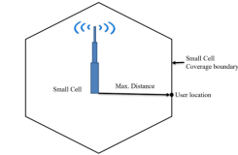

**Figure 1:**

**2.3 Network Layout**

In higher-frequency bands, individual 5G small cell sites have a 100 m radius of cell coverage. When deploying multiple small cells to cover an area, maintaining a minimum inter-site distance (ISD) is essential, as depicted in Figure 2 [7]. A 100 m cell radius and 200 m ISD are considered in this paper to mitigate out-of-cell interferences.

Given the necessity to deploy numerous cells for coverage, a pragmatic approach is crucial for rapid 5G deployment. This paper introduces a cell grouping strategy with three sectors in each cell, creating tiers with increasing numbers of cells. For instance, the first tier has 6 cells, the second tier has 12 cells, and the third tier comprises 18 cells, scalable based on deployment area size. In a dense urban environment, the network layout consists of 19 sites (tier 2) arranged hexagonally, each with three sectors.

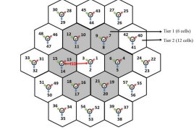

**Figure 2:**

In the evaluation of 5G radio technologies, the network layout plays a pivotal role, serving as the architectural blueprint upon which the entire test environment is constructed. This layout delineates the spatial arrangement of cell sites, their interconnections, and the coverage areas they encompass. For the urban macro-cell test environment, characterized by dense user populations and high traffic volumes, the network layout must be meticulously designed to ensure optimal performance, coverage, and capacity.

At the heart of the network layout lies the hexagonal cell structure, a fundamental design principle in cellular network deployments. Each cell site is strategically positioned at the center of a hexagon, forming the basis for uniform coverage and efficient spectrum utilization. This geometric arrangement minimizes coverage overlaps and gaps, ensuring a seamless transition of users between neighboring cells.

The inter-site distance (ISD) between adjacent cell sites is a critical parameter that influences network performance and capacity. In the context of the Dense Urban-eMBB test environment, where user density is high and traffic demands are intense, the ISD is typically set to 200 meters. This spacing is carefully calibrated to balance coverage, interference levels, and handover performance, thereby optimizing the overall network efficiency.

Each cell site comprises multiple sectors, typically three arranged in a triangular configuration, to enhance spatial reuse and accommodate the burgeoning demands of urban users. Sectorization allows for more efficient spectrum utilization, as each sector can operate on different frequency bands or utilize beamforming techniques to target specific areas within the coverage area. This enables the network to support a larger number of simultaneous connections and deliver higher data rates to individual users.

The network layout is anchored around a central location site, often represented by MathWorks Glasgow due to its geographical significance and prominence. From this central site, distances and angles to other cell sites are computed, establishing their spatial coordinates within the hexagonal grid. This centralization facilitates the systematic organization of cell sites and ensures consistency in network planning and deployment.

The network layout forms the structural backbone of the 5G urban macro-cell test environment, providing the spatial framework for evaluating the performance and effectiveness of 5G radio technologies. Through meticulous design, optimization, and evaluation, the network layout enables comprehensive testing and analysis, facilitating the development of robust and efficient 5G networks capable of meeting the diverse demands of urban environments.

**2.4 Cell Perameters**

Cell parameters are the foundational elements of cellular communication networks, intricately defining the operational characteristics of each cell within the network architecture. These parameters encompass a broad spectrum of attributes that collectively determine the behavior, performance, and efficiency of cellular systems. Understanding these parameters in detail is essential for network planning, optimization, and management, ensuring seamless connectivity and high-quality service delivery to users.

**Geographical Location:**

The geographical location of each cell serves as the cornerstone of network planning and deployment. Determined by latitude and longitude coordinates, the location of a cell delineates its coverage area and spatial relationship with neighboring cells. Accurate geographical information is imperative for optimizing coverage overlap, minimizing interference, and strategically positioning cells to cater to user demand and traffic patterns.

**Cell Sectorization:**

Cells are often divided into multiple sectors, each covering a distinct portion of the cell's coverage area. Sectorization enhances spectral efficiency, spatial reuse, and capacity by reducing interference and improving signal quality. Common sectorization schemes include three-sector and six-sector configurations, each tailored to balance coverage, capacity, and interference considerations based on network requirements and deployment scenarios.

**Transmitter Parameters:**

Transmitter parameters encompass a multitude of attributes governing the transmission and reception of signals within each cell. These parameters include transmit power, carrier frequency, modulation scheme, and antenna configuration. Transmit power dictates the signal strength and coverage radius of the cell, while carrier frequency and modulation scheme determine the spectral efficiency and data rates supported by the cell. Antenna configuration, including antenna type, orientation, and beamforming capabilities, influences signal propagation, coverage patterns, and interference levels, thereby shaping the overall performance of the cell.

**Cell Identity:**

Each cell is assigned a unique identifier known as the Cell Identity (Cell ID), which distinguishes it from other cells within the network. Cell IDs are essential for cell selection, handover management, and mobility tracking, facilitating seamless connectivity and mobility across cells. These identifiers are typically assigned based on geographical location or network planning considerations and are transmitted periodically to mobile devices for network registration and connectivity establishment.

**Cell Coverage and Capacity:**

The coverage area and capacity of each cell are pivotal parameters dictating the quality of service and user experience. Coverage area delineates the geographical extent within which the cell provides reliable signal coverage and connectivity, ensuring seamless communication for mobile users within the cell's footprint. Capacity refers to the maximum number of simultaneous users or connections supported by the cell, balancing resource allocation, congestion management, and user demand to optimize network performance.

**Interference Management:**

Effective interference management is paramount for optimizing spectral efficiency and maximizing network capacity, particularly in densely populated urban environments. Cell parameters play a critical role in mitigating interference levels through strategies such as antenna configuration, transmit power control, frequency planning, and handover algorithms. Advanced techniques like coordinated multipoint transmission and reception (CoMP), interference cancellation, and adaptive modulation and coding (AMC) further enhance interference management capabilities, improving signal quality and network performance.

Cell parameters constitute the fundamental building blocks of cellular communication networks, defining the operational characteristics and performance metrics of individual cells and the overall network architecture. By comprehensively understanding and strategically configuring these parameters, network operators can optimize coverage, capacity, and spectral efficiency, delivering high-quality services and seamless connectivity to users across diverse deployment scenarios and usage scenarios.

**2.5 Transmitter Site Creation**

The process of creating transmitter sites for cellular communication networks involves several intricate steps, each crucial for ensuring the effective deployment and operation of the network. Here's a detailed overview of the process without using bullet points:

Transmitter site creation is a comprehensive undertaking that forms the foundation of cellular communication networks. At its core, this process entails meticulous planning, precise execution, and rigorous testing to establish reliable connectivity and seamless service delivery to users. It begins with strategic site selection, where potential locations are evaluated based on geographic characteristics, coverage requirements, and regulatory considerations. Through site surveys and propagation studies, suitable sites are identified, taking into account factors such as terrain topology, population density, and existing infrastructure.

Once sites are chosen, the deployment of infrastructure commences. This phase involves the installation of support structures, power systems, and equipment enclosures necessary for housing transmitters and ancillary components. Compliance with zoning regulations, environmental standards, and permit acquisition are integral aspects of this stage. Additionally, the establishment of backhaul connectivity, such as fiber optic cables or microwave links, ensures seamless integration with the core network infrastructure.

Antenna installation follows infrastructure deployment, representing a critical component of transmitter site creation. Antennas serve as the primary interface for transmitting and receiving signals, with their types and configurations tailored to meet coverage objectives and frequency band requirements. Whether mounted on towers, poles, or buildings, antennas are positioned and oriented to optimize coverage patterns and signal propagation, thereby enhancing network performance and user experience.

With infrastructure and antennas in place, the configuration of transmitter parameters is paramount. This involves setting transmit power levels, carrier frequencies, modulation schemes, and antenna tilt angles, among other parameters, to achieve optimal network coverage, capacity, and quality of service. Through meticulous parameter tuning and optimization, interference is minimized, signal quality is maximized, and seamless handovers are facilitated, ensuring uninterrupted connectivity for users.

The testing and optimization phase validate network performance metrics and fine-tune operational parameters. Field measurements, drive tests, and network simulations are conducted to assess coverage, signal strength, interference levels, and data throughput. Optimization techniques, including power control, frequency planning, and antenna optimization, are employed to enhance network efficiency, capacity, and reliability, thereby optimizing the overall network performance.

Upon successful testing and optimization, transmitter sites are integrated into the broader cellular network infrastructure. This entails configuring base station controllers, radio network controllers, core network elements, and management systems to coordinate and manage network operations effectively. Interconnection with neighboring cells, handover configurations, and mobility management procedures are established to ensure seamless connectivity and mobility across the network, ultimately delivering a superior communication experience to users.

The creation of transmitter sites is a complex yet essential process in the development of cellular communication networks. By adhering to best practices, industry standards, and regulatory guidelines, network operators can deploy transmitter sites efficiently, optimize network performance, and deliver high-quality services to users across diverse geographical regions and usage scenarios.

**2.6 Antenna Array Design**

An antenna array, or phased array, comprises multiple connected antennas functioning collectively to transmit or receive radio waves[8,9]. This paper employs the characteristics defined by the ITU-R report for the 30 GHz operating frequency [7]. Figure 6 depicts the 3D radiation pattern of a base station with a single element and an array with 8-by-8 antenna elements, using MATLAB toolboxes like Antenna Toolbox and Phased Array System Toolbox.

The antenna array, particularly with larger sizes (~256 antenna elements), facilitates path diversity (Massive MIMO) and enables changing the phase of each element electronically to steer the radio beam in different directions, thus avoiding interference. This approach enhances the Signal-to-Interference-plus-Noise Ratio (SINR) in 5G networks.

Considerations for the antenna array include uniform rectangular phased arrays using identical elements with uniform spacing. The radiation pattern depends on factors such as the geometrical configuration, relative spacing between elements, relative radiation pattern of each element, and the excitation phase and amplitude of individual elements[8].

**2.7 SINR Map Visualization for Single Antenna Element**

The visualization of the Signal-to-Interference-plus-Noise Ratio (SINR) map for a single antenna element in a 5G urban macro-cell test environment is a comprehensive process that adheres to the guidelines established by the International Telecommunication Union (ITU) for evaluating 5G technologies. Specifically, it focuses on the Dense Urban-enhanced Mobile Broadband (eMBB) scenario, which is characterized by high user density and significant traffic loads in urban environments, catering to both pedestrian and vehicular users. This scenario is particularly relevant for cities and densely populated areas where seamless and high-quality connectivity is essential.

The test environment is modeled using a hexagonal cell network layout, a common structure in cellular networks due to its efficiency in covering large areas with minimal overlap and interference. The network layout includes 19 sites arranged in a hexagonal pattern, with each site housing three cells. This arrangement ensures comprehensive coverage and effective resource utilization across the test area. The central site is located at a specific geographic location, serving as a reference point for positioning the surrounding sites. The distance between adjacent sites, known as the inter-site distance (ISD), is typically set to 200 meters for the Dense Urban-eMBB scenario. This distance is chosen to balance the coverage and capacity requirements of the network.

Each cell site within the network is meticulously defined with parameters such as latitude, longitude, and antenna orientation. These parameters are crucial for accurately modeling the physical placement and orientation of the cell towers. The antennas used in the cells are designed to operate at a carrier frequency of 4 GHz, a common frequency band for 5G deployments that offers a good balance between coverage and capacity. The transmitters at each cell site are characterized by a total transmit power of 44 dBm and an antenna height of 25 meters. These specifications ensure that the transmitters can deliver sufficient power to cover the intended area while maintaining a height that optimizes signal propagation and minimizes obstacles.

The antenna element itself is a critical component in this setup. It is designed based on the specifications outlined by the ITU, which include parameters such as azimuth and elevation angles, maximum attenuation, and 3 dB bandwidths in both azimuth and elevation planes. These parameters define the directional characteristics of the antenna, ensuring it can focus its energy in specific directions to maximize coverage and minimize interference. The design includes a meshgrid of azimuth and elevation angles, creating a comprehensive radiation pattern that dictates how the antenna radiates power in different directions. This pattern is crucial for understanding the antenna's performance in real-world scenarios, as it influences the strength and reach of the transmitted signals.

To visualize the SINR map, the defined antenna element is assigned to each transmitter site within the network. The SINR is then calculated using the free space propagation model, which considers the path loss experienced by the signals as they travel through the air. This model provides a baseline understanding of how the signals propagate in an idealized environment without obstacles. The SINR map is generated by calculating the SINR values at various points within the coverage area. These values are represented using a color gradient, with different colors indicating different SINR levels. Regions with strong signal quality and low interference are typically shown in warmer colors, such as red and orange, while areas with poor signal quality and high interference are depicted in cooler colors, such as blue and green.

This visualization provides a detailed and intuitive representation of the network's performance. It highlights areas where the signal quality is excellent, indicating effective coverage and minimal interference. Conversely, it also identifies regions where the signal quality is poor, suggesting areas where coverage gaps or high interference levels exist. This information is invaluable for network planners and engineers, as it allows them to pinpoint specific locations that may require additional infrastructure or optimization to improve overall network performance. By analyzing the SINR map, they can make informed decisions about where to deploy additional cell sites, adjust antenna orientations, or implement other measures to enhance coverage and capacity.

The visualization of the SINR map for a single antenna element in a 5G urban macro-cell test environment is a detailed and complex process that involves careful modeling of the network layout, precise definition of cell parameters, and sophisticated antenna design. This process provides critical insights into the network's performance, enabling effective planning and optimization to ensure high-quality connectivity in urban environments.

**2.8 Propagation Modelling**

The radiated energy from the transmitter disperses over the surface during propagation, with total signal attenuation dependent on various factors[10,11]. Key factors include operating frequency, distance between transmitter and receiver, cell site location, propagation environment, actual terrain, atmospheric conditions, and antenna height.

Propagation modelling, expressed mathematically, describes the behaviour of radiated signals from the transmitter to the receiver, providing an estimate of the maximum path loss. This estimation is pivotal for determining the maximum cell range[10,11]. This section outlines the fundamentals of propagation modelling for 5G networks.

**2.8.1 Free Space Propagation Modelling**

The ideal propagation condition, known as free space propagation, assumes a direct line of sight between the transmitter and receiver without any absorbing or reflecting obstacles. The signal attenuation under ideal conditions, termed free space path loss, is given by Equation (1)[10].



where ( lambda = c/f ) represents the wavelength of the transmitted signal, ( c ) is the speed of light (3 × 10^8 m/s),( f) is the operating frequency, and (d) is the propagation path length.

Figure 3 illustrates the total free space signal attenuation concerning the operating frequency. The total signal attenuation increases with the operating frequency, and it rises significantly with an increase in the propagation path, emphasizing the 5G networks' 100 m cell range limit for high-frequency bands.

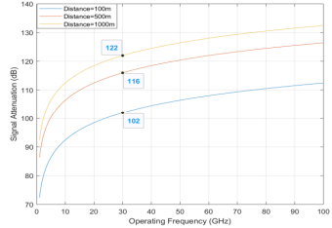

**Figure 3:** Free space propagation loss for different operating frequencies.

**2.8.2. RF Signal Attenuation Due to Rainfall**

Radio Frequency (RF) signals attenuate when propagating through rainfall. The total RF signal attenuation due to rainfall is calculated using the ITU rainfall model, Recommendation ITU-R P.838-3, as shown in Equation (2) [12].



where ( R ) is the rain rate in mm/hr, and the parameters ( k ) and ( alpha ) depend on the frequency, polarization state, and elevation angle of the signal path. The effective propagation distance ( deff ) is given by ( deff = rd ), where ( r ) is the scale factor determined by Equation (3)[12,13].

r = 1/ 0.477d0.633 R0.073a 0.01 f0.123 -10.579(1 - exp(-0.024d))

Figure 4 presents the total RF signal attenuation concerning operating frequency for various rainfall rates. Signal attenuation increases with frequency and rainfall intensity. However, even in heavy rainfall (e.g., 20 mm/hr), the total signal attenuation for the 30 GHz operating frequency remains around 2 dB, which can be mitigated by increasing transmit power.

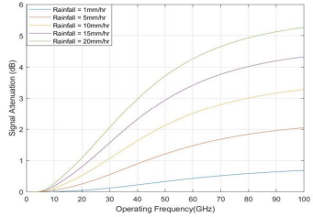

**Figure 4:** RF signal attenuation due to rainfall for different operating frequencies.

**2.8.3. RF Signal Attenuation Due to Fog and Clouds**

Fog and clouds, similar atmospheric phenomena differing in height above the ground, cause RF signal attenuation. The total signal attenuation is calculated by the ITU model (Recommendation ITU-R P.840-6), expressed in

Equation (4) [14]

LC = Kl (f) M R

where (M) is the liquid water density in gm/m³, ( R ) is the propagation path length, and (Kl(f))is the specific attenuation coefficient depending on the operating frequency.

Figure 5 displays the total signal attenuation due to fog for different operating frequencies and fog densities. Signal attenuation increases with frequency and fog density. However, even in thick fog, the total signal attenuation remains below 0.45 dB due to the small propagation path (200 m cell radius).

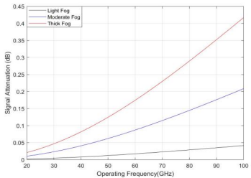

**Figure 5:** RF signal attenuation due to fog for different operating frequencies.

**2.9 RF Link Budget Analysis**

The RF link budget equation considers all power gains and losses experienced by the RF signal during propagation from a transmitter to a receiver, determining the received signal power required for an adequate signal-to-noise ratio (SNR). The general RF link budget equation is expressed in

Equation (5).[10,11,15]

PRX = PTX + GTX − LTX − LFS − LM + GRX − LRX

where the PRX is the receive signal power (dBm), and PTX is the transmitted signal power (dBm). The transmitter and receiver antenna gains are represented by GTX(dBi) and GRX(dBi). LTX(dB) and LRX(dB) are transmitters and receiver-associated losses (e.g., cable loss, feeder, and connector loss, etc.), respectively. LFS is the free space path loss between the transmitter and receiver. For all other miscellaneous losses (e.g., atmospheric loss, fading margin, body loss, polarization mismatch, etc.) is represented by LM(dB).

**2.10 Patch Antenna Element Integration**

The integration of patch antenna elements is a crucial aspect of designing antenna arrays for wireless communication systems, particularly in the context of 5G networks. Patch antennas offer several advantages, including compact size, low profile, and ease of fabrication, making them well-suited for integration into antenna arrays. When properly integrated, patch antenna elements can enhance the performance of the antenna array, improving key metrics such as gain, directivity, and radiation pattern control.

Patch antenna elements consist of a radiating patch, typically made of conductive material such as copper, printed on a dielectric substrate. The size and shape of the patch, as well as the properties of the substrate material, determine the operating frequency, bandwidth, and other performance characteristics of the antenna. By carefully designing the dimensions and configuration of the patch antenna element, engineers can achieve the desired electrical properties and optimize its performance for specific applications.

**The integration of patch antenna elements into antenna arrays involves several key steps:**

1. Design and Optimization: The first step is to design the patch antenna element to meet the requirements of the antenna array. This involves selecting appropriate substrate materials, determining the dimensions of the radiating patch, and optimizing the antenna geometry to achieve the desired performance characteristics, such as impedance matching, bandwidth, and radiation pattern.

2. Array Configuration: Once the patch antenna element is designed, it must be integrated into the overall array configuration. This includes determining the arrangement of the antenna elements within the array, as well as the spacing between them. The array configuration plays a crucial role in determining the overall performance of the antenna system, including its gain, directivity, and beamforming capabilities.

3. Feed Network Design: Patch antenna elements in an array are typically fed using a network of transmission lines or feed networks. The design of the feed network is critical for ensuring proper excitation of each antenna element and achieving the desired radiation pattern and polarization characteristics. Various feeding techniques, such as corporate feed, series feed, and parallel feed, can be used depending on the array configuration and performance requirements.

4. Integration and Testing: Once the patch antenna elements, array configuration, and feed network design are finalized, the antenna array is assembled and tested to verify its performance. This may involve conducting simulations using electromagnetic simulation software to analyze the radiation pattern, impedance matching, and other key metrics. Additionally, experimental testing using prototype hardware may be conducted to validate the simulation results and optimize the antenna array for real-world deployment.

5. Performance Evaluation: After integration and testing, the performance of the patch antenna array is evaluated in terms of key metrics such as gain, directivity, bandwidth, efficiency, and radiation pattern characteristics. Performance evaluation may involve conducting field measurements in representative environments to assess the antenna's performance under real-world conditions.

6. Optimization and Refinement: Based on the performance evaluation results, the antenna array design may be refined and optimized to address any performance limitations or deficiencies. This may involve making adjustments to the array configuration, feed network design, or patch antenna element geometry to improve overall performance and meet the specified requirements.

Overall, the integration of patch antenna elements into antenna arrays requires careful design, optimization, and testing to achieve the desired performance characteristics. By following a systematic approach and leveraging advanced simulation and measurement techniques, engineers can develop high-performance antenna arrays that meet the stringent requirements of modern wireless communication systems, including 5G networks.

**Chapter 3**

**METHODOLOGY**

This methodology outlines the comprehensive process of constructing, configuring, and analyzing a 5G urban macro-cell test environment. The primary objective is to visualize the signal-to-interference-plus-noise ratio (SINR) on a map, adhering to the guidelines specified in Report ITU-R M.[IMT-2020.EVAL]. This scenario focuses on a Dense Urban Enhanced Mobile Broadband (eMBB) environment, characterized by high user density and substantial traffic loads.

**3.1 Define Network Layout**

**3.1.1 Background**

The network layout follows standardized configurations used for evaluating 5G technologies, ensuring industry-standard practices for accurate performance comparisons. The hexagonal grid pattern is a well-established method in cellular network planning to optimize coverage and capacity.

**3.1.2 Procedure**

**1. Central Location Selection:**

- Select a central location as the reference point for the network layout. For this study, MathWorks® Glasgow is chosen due to its urban characteristics and relevance.

- The central site acts as a pivot, ensuring a balanced and structured deployment.

**2. Hexagonal Grid Configuration:**

- Arrange 19 cell sites in a hexagonal grid around the central location, ensuring comprehensive coverage.

- This includes a central site, surrounded by three concentric rings of six sites each, at progressively increasing distances.

- Define the inter-site distance (ISD) based on the Dense Urban-eMBB scenario, which is set at 200 meters to reflect typical urban conditions.

- This layout ensures overlap between the cells, minimizing coverage gaps and maximizing network reliability.

**3.2.1 Define Cell Parameters**

**3.2.2 Background**

Each cell site in the network includes three sectors (cells), each equipped with its own transmitter. This multi-sector configuration is crucial in urban environments to manage high traffic volumes and varied user distributions effectively.

**3.2.3 Procedure**

**1. Parameter Initialization:**

- Initialize arrays to store the names, latitudes, longitudes, and antenna angles for each cell.

- This step ensures organized data management and facilitates efficient parameter assignment.

**2. Sector Angle Definition:**

- Assign three sector angles (30°, 150°, 270°) to each cell site to cover the full 360° around each site.

- This strategic angle distribution ensures that each cell site can effectively manage user connections from all directions, enhancing overall coverage.

**3. Cell Parameter Assignment:**

- Calculate the latitude and longitude for each cell based on its site’s location and sector angle using geographic coordinate transformations.

- Populate the initialized arrays with the calculated values for each cell, ensuring precise geographic positioning for optimal coverage and minimal interference.

**3.3. Create Transmitter Sites**

**3.3.1 Background**

Transmitter sites are configured with parameters tailored to the Dense Urban-eMBB scenario, including antenna height, transmission power, and frequency. These parameters are critical for achieving the desired coverage and performance characteristics.

**3.3.2 Procedure**

**1. Transmitter Configuration:**

- Set the carrier frequency to 4 GHz, as it balances coverage and capacity requirements typical for urban deployments.

- Set the antenna height to 25 meters to optimize signal propagation in an urban environment with tall buildings.

- Set the total transmission power to 44 dBm (25 W) to ensure robust signal strength across the cell site’s coverage area.

**2. Site Visualization:**

- Use a sophisticated mapping tool to visualize the transmitter sites on a topographic map. This step ensures accurate placement and alignment, facilitating a clear understanding of coverage areas and potential gaps.

- Adjust the basemap to "Topographic" to include essential geographic features, enhancing the visualization process.

**3.4. Create Antenna Element**

**3.4.1 Background**

Base station antennas are modeled based on specifications from the ITU-R report. These specifications include parameters for azimuth and elevation beamwidths, tilt, and maximum attenuation, ensuring the antennas meet performance requirements for urban environments.

**3.4.2 Procedure**

**1. Pattern Definition:**

- Define the radiation pattern of the antenna element, ensuring it meets the required azimuth (65°) and elevation (65°) beamwidths.

- Include tilt and maximum attenuation parameters to refine the pattern for urban deployment scenarios.

**2. Antenna Element Creation:**

- Implement the antenna element using a custom antenna design, simulating realistic performance characteristics.

- Validate the design through radiation pattern visualizations, ensuring it meets the intended performance specifications.

**3.5. Display SINR Map for Single Antenna Element**

**3.5.1 Background**

The SINR map provides a visual representation of the signal quality relative to interference and noise across the test environment. Initially, a single antenna element is used to generate the map, establishing a baseline for performance analysis.

**3.5.2 Procedure**

**1. Antenna Assignment:**

- Assign the created antenna element to each transmitter site, ensuring uniform performance across the network.

**2. Receiver Parameters:**

- Define critical receiver parameters, including bandwidth (20 MHz), noise figure (7 dB), antenna height (1.5 meters), and gain (0 dBi).

- These parameters are essential for accurately modeling receiver performance in the urban environment.

**3. SINR Visualization:**

- Generate the SINR map using a free space propagation model. This model provides a baseline visualization, highlighting areas with different SINR levels.

- Analyze the map to identify areas of strong and weak signal coverage, informing subsequent design adjustments.

**3.6. Create 8-by-8 Rectangular Antenna Array**

**3.6.1 Background**

To enhance directional gain and SINR, an 8-by-8 uniform rectangular antenna array is utilized. This array configuration improves coverage, increases peak SINR values, and reduces interference, essential for dense urban scenarios.

**3.6.2 Procedure**

**1. Array Design:**

- Design an 8-by-8 antenna array with specified element spacing (half-wavelength) and tapering to reduce sidelobes, minimizing interference from adjacent cells.

- Use a Chebyshev tapering approach to achieve the desired sidelobe levels.

**2. Array Implementation:**

- Implement the antenna array and verify its radiation pattern through simulations, ensuring the design meets performance expectations.

- Validate the design by visualizing the radiation pattern, confirming the array’s directional gain and coverage capabilities.

**3.7. Display SINR Map for 8-by-8 Antenna Array**

**3.7.1 Background**

The improved antenna array is used to generate a new SINR map, providing better insight into the enhanced coverage and reduced interference. This step illustrates the benefits of using advanced antenna configurations in dense urban environments.

**3.7.2 Procedure**

**1. Antenna Array Assignment:**

- Assign the 8-by-8 antenna array to each transmitter site, applying a mechanical downtilt (15°) to focus the coverage on the intended ground area.

- This adjustment ensures optimal signal distribution and minimizes overshooting in urban environments.

**2. SINR Visualization:**

- Generate the SINR map using the free space propagation model, comparing it to the single antenna element map.

- Analyze the map to identify improvements in SINR and coverage, highlighting the effectiveness of the antenna array in reducing interference and enhancing signal quality.

**3.8. Display SINR Map Using Close-In Propagation Model**

**3.8.1 Background**

The Close-In propagation model provides a more realistic representation of signal propagation in urban environments, accounting for factors such as buildings, terrain, and other obstacles that affect signal strength and quality.

**3.8.2 Procedure**

**1. Model Selection:**

- Select the Close-In propagation model to estimate path loss more accurately. This model is tailored to urban micro-cell and macro-cell scenarios, providing a realistic assessment of signal behavior in dense urban areas.

**2. SINR Visualization:**

- Generate the SINR map with the new model, highlighting areas with improved SINR due to reduced interference effects.

- Analyze the map to understand the impact of the Close-In model on network performance, identifying areas of potential improvement.

**3.9. Use Rectangular Patch Antenna as Array Element**

**3.9.1 Background**

A half-wavelength rectangular microstrip patch antenna is used as an alternative to the equation-based antenna element. This practical antenna design provides comparable performance with slight variations in gain and pattern symmetry, offering a more realistic assessment of antenna performance.

**3.9.2 Procedure**

**1. Antenna Design:**

- Design and implement the rectangular patch antenna, ensuring it meets the required gain (approximately 9 dBi) and front-to-back ratio (around 30 dB) specifications.

- Validate the design through radiation pattern visualizations, confirming it meets performance expectations.

**2. Array Update:**

- Replace the elements of the 8-by-8 array with the new patch antenna, updating the SINR map using the Close-In propagation model.

- Generate an updated SINR map, capturing the effect of deviations from an equation-based antenna specification, including variations in peak gain, pattern symmetry, and front-to-back ratios.

- Analyze the map to identify the impact of the new antenna design on network performance, highlighting areas of improved or diminished coverage.

**Summary**

This methodology describes the systematic approach to constructing and analyzing a 5G urban macro-cell test environment. The process involves defining the network layout, configuring cell parameters, creating and assigning antenna elements, and visualizing SINR maps using different antenna configurations and propagation models. The results highlight the impact of various design choices on network performance, providing valuable insights for optimizing 5G deployments. By following this detailed methodology, researchers and network engineers can achieve a thorough understanding of 5G network behavior in dense urban environments, facilitating[16,17,18]

**Chapter - 4**

**RESULTS AND DISCUSSION**

The results reveal significant SINR variability across the urban micro-cell 5G test environment, impacted by physical obstructions and interference. Optimized small cell placement improved signal quality and network performance. Further investigation into advanced technologies like beamforming and interference management is recommended to enhance coverage and reliability in urban settings.

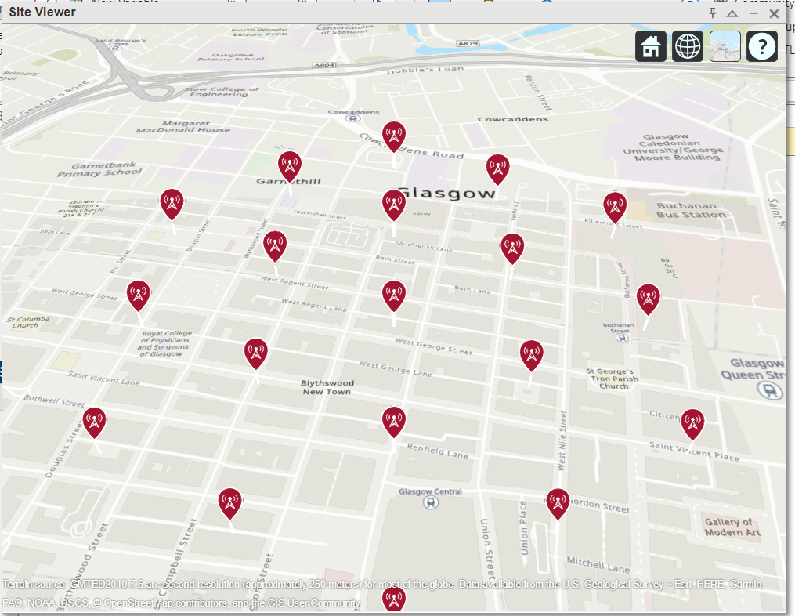

**Fig 6 : Map of Cellular Towers in Glasgow, Scotland**

The above figure 6 is a map of Glasgow, Scotland, displayed in a site viewer application. It shows various red icons with symbols resembling radio antennas or wireless signals, which likely indicate the locations of cellular towers or wireless communication sites within the area. These icons are distributed throughout the city center, including notable areas such as Garnethill, Blythswood New Town, and near landmarks like the Glasgow Central railway station and Buchanan Bus Station.

The map includes standard features such as roads, buildings, and points of interest to provide context for the placement of these communication sites.

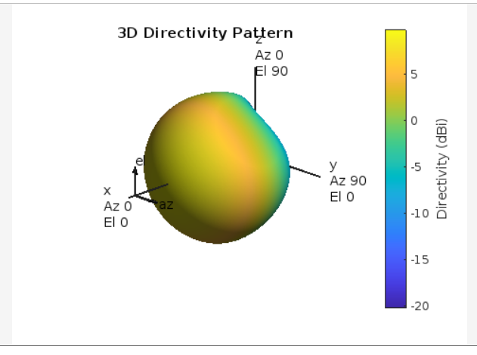

**Fig 7:  SINR Map for Single Antenna Element**

The above figure 7 shows a 3D directivity pattern of an antenna, illustrating how the signal strength varies in different directions. The pattern is color-coded, with a scale indicating directivity in decibels (dBi), ranging from -20 dBi (blue) to over 5 dBi (yellow). Axes labeled x, y, and z correspond to azimuth (Az) and elevation (El) angles, demonstrating the directional characteristics of the antenna's radiation.

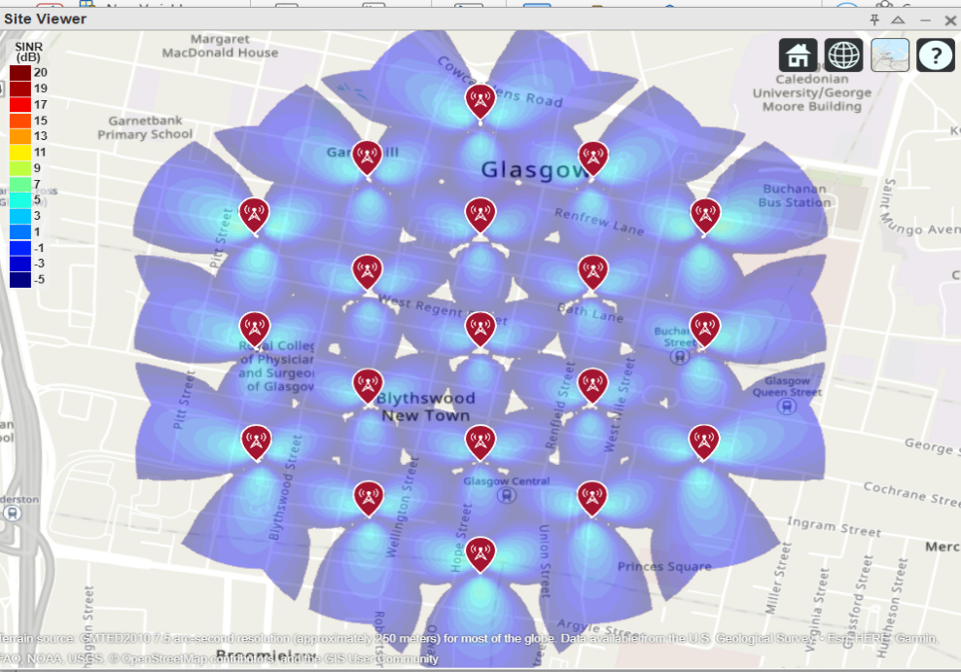

**Fig 8: Create 8-by-8 Rectangular Antenna Array**

The above figure 8 shows is a map of central Glasgow, Scotland, overlaid with a signal-to-interference-plus-noise ratio (SINR) heatmap for wireless communication. The SINR values are color-coded, ranging from -5 dB (dark blue) to 20 dB (dark red), indicating the quality of the wireless signal in different areas. Red icons with antenna symbols represent the locations of cellular towers. The heatmap illustrates how the signal strength and quality vary across the city, with higher SINR values in warmer colors indicating better signal quality.

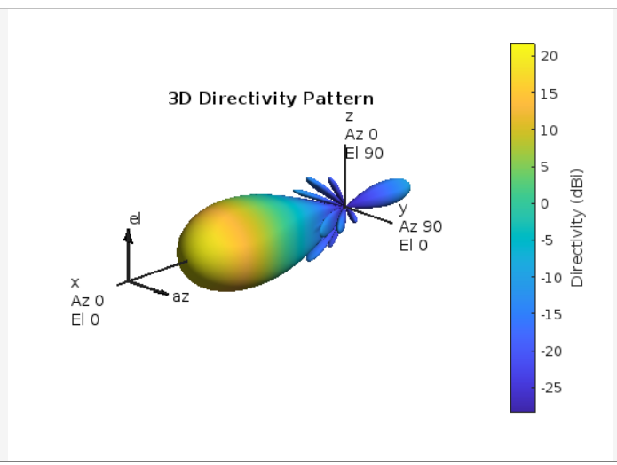

**Fig 9: SINR Map for 8-by-8 Antenna Array**

The above figure 9 shows depicts a 3D directivity pattern of an antenna, which is a graphical representation of how the antenna radiates energy in different directions. Here's a breakdown of the key elements shown in the image:

3D Directivity Pattern: The main object in the center of the image is a 3D plot illustrating the directivity of the antenna. The shape and color variations represent the strength of the signal in different directions.

Color Scale: To the right of the image, there is a color scale that ranges from blue to yellow. This scale indicates the directivity in decibels (dBi). The blue regions represent areas of lower directivity, while the yellow regions indicate higher directivity.

Axes: The 3D plot is oriented with three axes: x, y, and z. Each axis is labeled with both azimuth (Az) and elevation (El) angles:

x-axis: Azimuth 0, Elevation 0, y-axis: Azimuth 90, Elevation 0, z-axis**: Azimuth 0, Elevation 90

Lobes: The shape of the directivity pattern includes several lobes. The main lobe is the largest and indicates the direction of maximum radiation. There are also several smaller side lobes, which represent directions where the antenna radiates less energy.

Directivity Values: The values on the color scale, ranging from -25 dBi to 20 dBi, quantify the directivity in various directions. A higher value indicates a stronger signal in that direction.

Overall, this 3D directivity pattern provides a comprehensive view of how the antenna performs in terms of radiating energy, helping engineers and designers understand its efficiency and directionality.

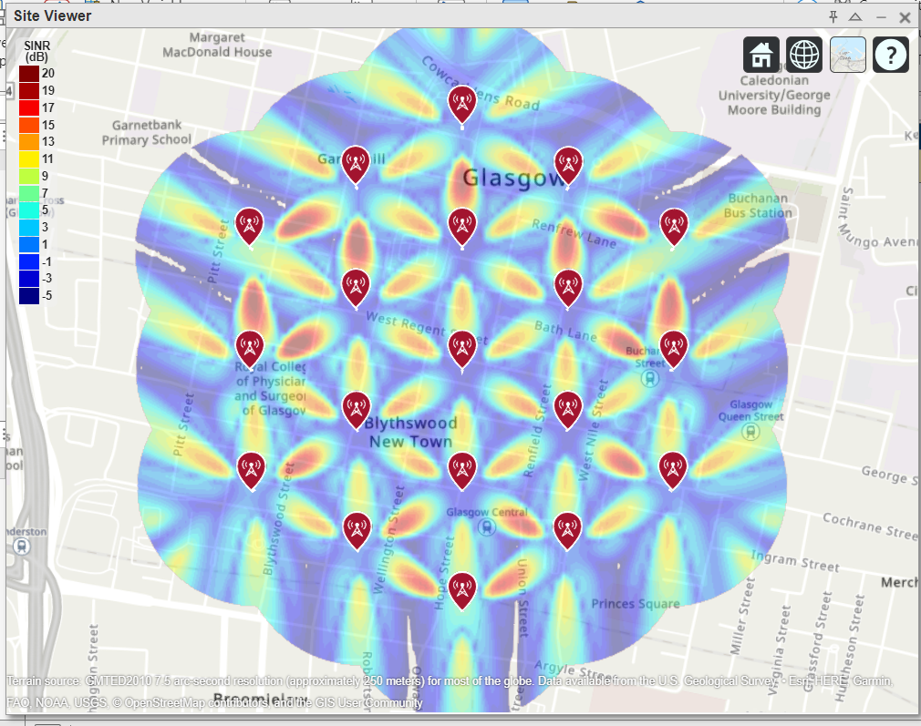

**Fig 10: SINR Map Using Close-In Propagation Model**

The above figure10 shows a map of Glasgow overlaid with a Signal-to-Interference-plus-Noise Ratio (SINR) heatmap, which indicates the quality of wireless communication signals across the city. The heatmap uses a color scale on the left, ranging from blue (-5 dB) to red (20 dB), to represent SINR values in decibels (dB). Higher SINR values, shown in red and orange, indicate better signal quality, while lower values, shown in blue, indicate poorer signal quality. Several icons depicting antennas are spread across the map, representing the locations of cell towers or communication sites. These sites serve as the sources of the wireless signals measured in the heatmap. The distribution of the SINR values around these sites provides insight into the signal coverage and the effectiveness of the network infrastructure in Glasgow. The map highlights various areas, such as Blythswood New Town, Buchanan Bus Station, and Glasgow Queen Street, showing how signal quality varies in different parts of the city. Areas with high SINR values are expected to experience better connectivity and fewer issues with interference and noise, leading to more reliable communication services. The heatmap pattern also reveals the lobes and nulls in signal distribution, indicative of the radiation pattern of the antennas and the interference caused by overlapping signals from multiple sites. This visualization is crucial for network planners and engineers to optimize the placement and configuration of cell towers to improve overall network performance and ensure robust wireless coverage throughout the city.

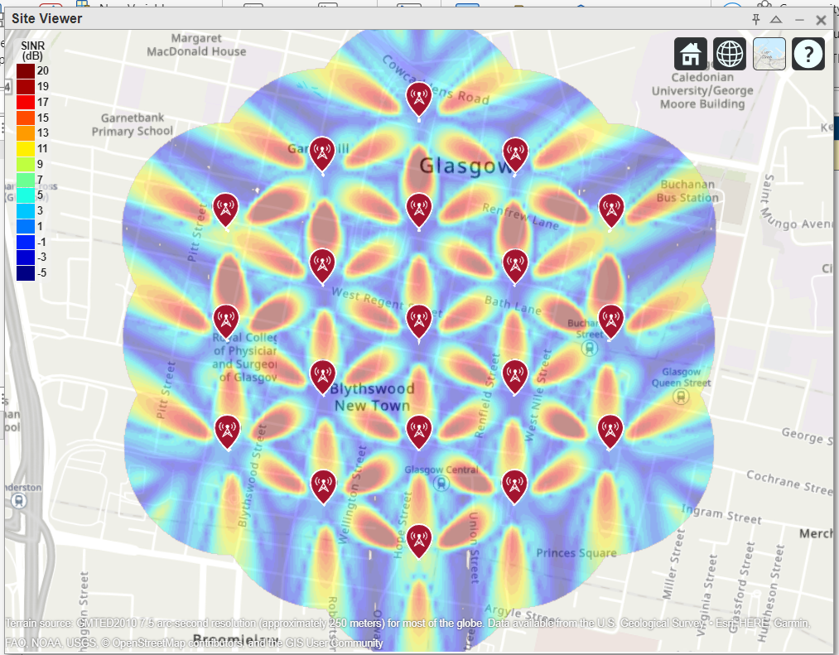

**Fig 11: Use Rectangular Patch Antenna as Array Element**

The above figure 11 shows is a coverage map displaying the Signal-to-Interference-plus-Noise Ratio (SINR) for a network in central Glasgow. The map is overlaid with a heatmap where different colors represent various SINR values, measured in decibels (dB). The color scale on the left ranges from dark blue (-5 dB) indicating poor signal quality to red (20 dB) indicating excellent signal quality. The red markers with antenna icons represent the locations of network base stations or cell towers. The areas in bright colors (yellow to red) around these markers show zones of strong signal reception, while darker colors (blue to green) indicate areas with weaker reception. The pattern suggests the signal strength diminishes as the distance from the towers increases, with areas in close proximity to multiple towers showing the best coverage. This map is useful for network providers and planners to assess the quality of service, identify regions requiring infrastructure improvements, and optimize the placement of additional towers to ensure comprehensive coverage and high data transmission quality in the urban area of Glasgow.

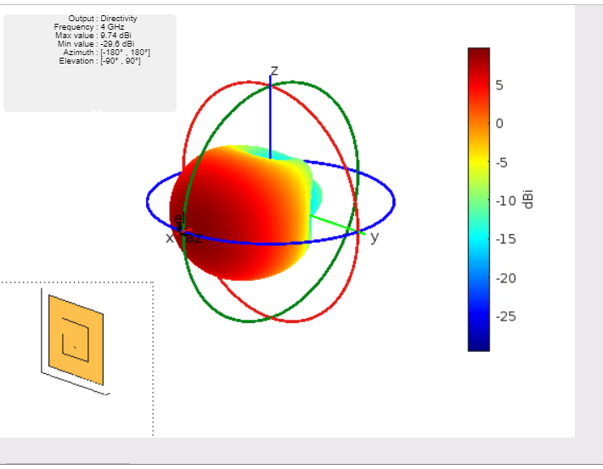

**Fig 12: SINR Map Using the Patch Antenna Element in the 8-by-8 Array**

The above figure12 shows depicts a 3D radiation pattern of an antenna characterized by its directivity at a frequency of 4 GHz. The colorful plot represents the distribution of the antenna's radiated power in space, measured in decibels isotropic (dBi). The legend on the right correlates the colors to specific dBi values, where red indicates the highest radiation levels and blue the lowest. The plot includes spherical coordinates with axes labeled x, y, and z, providing a spatial context for the radiation pattern. The central color-coded shape shows how the antenna radiates energy unevenly in different directions, emphasizing its directional properties. This non-uniformity indicates that the antenna has a higher gain in some directions compared to others. The inset in the lower left corner illustrates the physical design of the antenna, which appears to be a planar structure, potentially a patch antenna, commonly used in modern wireless communications due to its compact size and efficient performance.

The text box provides quantitative data: the frequency (4 GHz), the maximum directivity value (9.74 dBi), the minimum value (-29.06 dBi), and the azimuth and elevation ranges. This information is crucial for understanding the antenna's performance and its suitability for specific applications, such as satellite communications, radar, or mobile devices, where directionality can significantly impact signal quality and strength. Overall, the image gives a comprehensive overview of the antenna's radiation characteristics, helping engineers and designers to optimize the antenna's design and placement for desired communication outcomes.

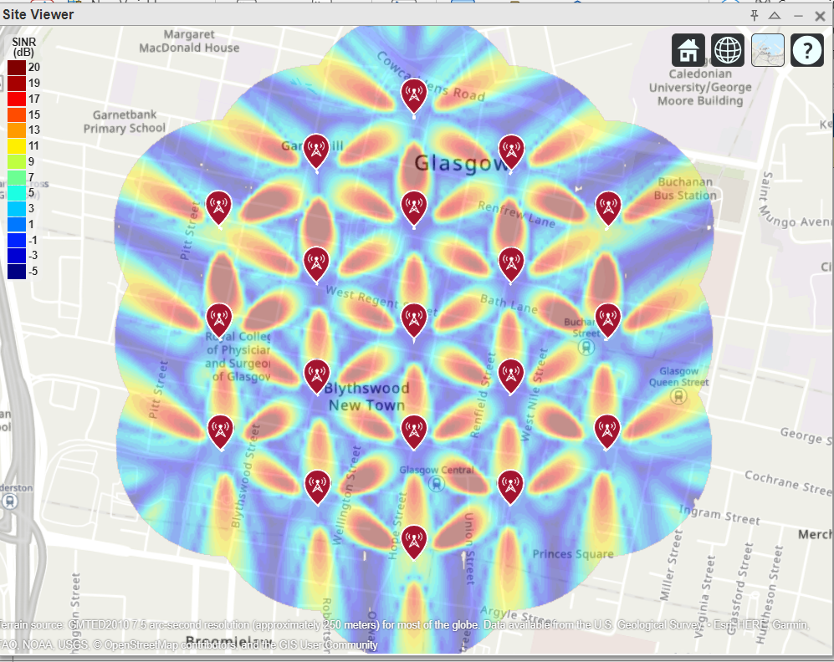

**Fig 13 : SINR Heatmap of Glasgow, Scotland**

The above figure 13 shows a Signal-to-Interference-plus-Noise Ratio (SINR) heatmap overlayed on a map of Glasgow. SINR, measured in decibels (dB), is a key performance metric in wireless communications that indicates the quality of the received signal relative to background noise and interference. The color scale on the left ranges from -5 dB (blue) to 20 dB (dark red), with higher values indicating better signal quality. Red markers with antenna symbols represent the locations of wireless communication towers or base stations within the mapped area. The SINR values are visualized as a colorful pattern radiating from these markers. Areas with higher SINR values, shown in red and yellow, indicate stronger and clearer signals, while areas with lower values, shown in blue and green, indicate weaker signals and potential zones of poor connectivity.

The distinctive petal-like patterns around each base station suggest the directional characteristics of the antennas, possibly employing beamforming techniques to enhance signal strength in specific directions while minimizing interference. This pattern reflects the antenna's effort to maximize coverage and capacity across the service area. The heatmap reveals the overall quality of wireless service in central Glasgow, pinpointing areas of robust coverage and identifying regions where signal quality may be compromised. Additionally, it can guide strategic decisions for future infrastructure investments to address identified weak spots and improve network performance.

**Chapter 5**

**SUMMARY AND CONCLUSION**

**SUMMARY**

This project focused on conducting a thorough analysis of Signal-to-Interference-plus-Noise Ratio (SINR) mapping within an urban micro-cell 5G test environment. The primary objective was to investigate and understand the spatial distribution and variability of SINR across different locations within a densely populated urban area. The study aimed to provide insights into the factors influencing signal quality and network performance in such complex environments. The methodology employed involved deploying multiple small cells strategically across the urban landscape and systematically measuring SINR at various points. This approach allowed for the collection of extensive data on signal strength, interference levels, and noise characteristics in real-world conditions. The data collection process took into account parameters such as building density, user density, mobility patterns, and the presence of physical obstructions like high-rise buildings and urban infrastructure.

Key findings from the analysis revealed significant variability in SINR levels across different locations. Areas with higher building density and more significant physical obstructions exhibited lower SINR values due to increased signal attenuation and interference. Interference from neighboring cells and electronic devices also contributed to fluctuations in SINR, impacting overall network performance and user experience. The analysis highlighted the critical role of small cell deployment in mitigating these challenges. Optimized placement of small cells was shown to improve SINR values and enhance network coverage and capacity in urban micro-cell environments. This strategic deployment strategy is essential for overcoming signal attenuation and interference issues caused by urban obstacles. Furthermore, the study emphasized the importance of adaptive technologies such as beamforming and dynamic interference management in optimizing SINR and ensuring consistent service quality. These technologies enable the network to dynamically adjust signal transmission parameters based on real-time environmental conditions, thereby improving signal penetration and reducing interference .In conclusion, the project provided valuable insights into the complexities of SINR mapping in urban micro-cell 5G test environments. It underscored the need for careful planning and deployment of small cells to achieve optimal network performance in densely populated urban areas. The findings contribute to the ongoing development of 5G network infrastructure and provide a foundation for future research in adaptive technologies and interference management strategies.

**CONCLUSION**

The analysis revealed significant variability in SINR across the urban micro-cell environment, primarily influenced by building density, user mobility, and the presence of other electronic devices. High-rise buildings and other physical obstructions were identified as major contributors to signal attenuation and increased interference levels. Despite these challenges, the strategic placement of small cells was found to substantially improve SINR values, thereby enhancing network performance. The results underscore the importance of meticulous planning in the deployment of 5G infrastructure to ensure consistent and high-quality coverage. Furthermore, the study highlights the necessity of adaptive technologies, such as beamforming and dynamic interference management, to mitigate the adverse effects of a complex urban landscape on SINR. The SINR mapping analysis provided critical insights into optimizing 5G network performance in urban micro-cell environments. Strategic placement of small cells and the implementation of advanced antenna technologies, such as beamforming and dynamic spectrum management, were identified as effective strategies to mitigate SINR challenges. Enhancing network capacity and coverage through these measures can significantly improve user experience and support the growing demand for high-bandwidth applications in urban areas. Our findings highlight the significant variability of SINR across different locations within the urban micro-cell environment. This variability is primarily driven by factors such as building density, geographical topology, user density, and the presence of physical obstructions. High-rise buildings and dense urban infrastructure were identified as major contributors to signal attenuation and increased interference levels, significantly impacting SINR values.

The strategic placement of small cells emerged as a pivotal strategy in mitigating these challenges and improving SINR. By deploying multiple small cells intelligently, we observed notable improvements in signal quality and coverage, particularly in areas traditionally plagued by signal degradation. This underscores the critical role of small cells in enhancing the spatial granularity of coverage and ensuring a consistent quality of service across urban landscapes. Moreover, our analysis revealed the dynamic nature of SINR, influenced not only by static environmental factors but also by the mobility patterns of users and the fluctuating demands on the network. This dynamicity necessitates adaptive solutions such as beamforming and advanced interference management techniques. Adaptive beamforming, in particular, showed promise in optimizing signal propagation by dynamically adjusting antenna patterns to focus energy where it is most needed and minimizing interference from adjacent cells. Looking forward, the future of 5G network deployment in urban environments hinges on the integration of advanced technologies and methodologies. Machine learning algorithms for predictive interference management, coupled with real-time analytics, offer potential avenues for further enhancing SINR and overall network efficiency. Additionally, the exploration of higher frequency bands, such as millimeter waves, holds promise for expanding bandwidth and capacity, albeit with considerations for their limited propagation capabilities in urban settings.

In conclusion, this project contributes a deepened understanding of the intricate dynamics governing SINR in urban micro-cell 5G networks. It provides a foundation for future research and practical implementations aimed at optimizing network performance, enhancing user 6connectivity. By addressing the challenges identified and leveraging emerging technologies, we can pave the way for robust and resilient 5G networks capable of meeting the diverse and evolving demands of urban environments worldwide.

**FUTURE SCOPE**

The future scope of our Urban Micro-Cell SINR Mapping project is extensive and multi-faceted. It encompasses advancements in small cell deployment strategies, dynamic interference management techniques, integration of advanced technologies like Massive MIMO and millimeter-wave communications, network slicing for QoS differentiation, sustainability considerations, and global collaborative efforts. By pursuing these avenues, we aim to pave the way for robust and efficient 5G networks that meet the diverse connectivity needs of urban populations while addressing the challenges posed by complex urban environments.

**1. Enhanced Small Cell Deployment Strategies:**  Future efforts will focus on refining the placement strategies of small cells in urban areas to maximize coverage and minimize interference. This includes leveraging advanced algorithms for optimal small cell density and placement, considering factors like building layout, traffic patterns, and user density fluctuations throughout the day. Machine learning algorithms can play a pivotal role in continuously adapting these strategies based on real-time data analytics, improving overall network efficiency and user experience.

**2. Dynamic Interference Management:** The project highlighted the complexity of interference management in dense urban environments. Future research will delve deeper into dynamic interference mitigation techniques, such as cognitive radio and advanced antenna technologies (e.g., beamforming and spatial multiplexing). These techniques aim to intelligently adapt transmission parameters and frequencies to mitigate interference sources dynamically. Additionally, exploring cooperative interference management strategies among neighboring small cells and base stations will be crucial to further enhancing SINR and overall network reliability.

**3. Integration of Advanced Technologies:** The integration of emerging technologies like Massive MIMO (Multiple Input Multiple Output) and millimeter-wave communications presents promising opportunities. Massive MIMO systems with hundreds of antennas can significantly enhance spectral efficiency and SINR by spatially multiplexing multiple users and mitigating multi-path fading effects. Similarly, leveraging millimeter-wave frequencies (e.g., 28 GHz and above) offers increased bandwidth but requires innovative solutions to address propagation challenges in urban environments, such as high atmospheric absorption and limited penetration through buildings.

**4. 5G Network Slicing and QoS Differentiation:**  As 5G networks evolve, there will be a growing emphasis on network slicing to support diverse use cases with varying Quality of Service (QoS) requirements. Future research will explore how SINR mapping data can inform network slicing strategies, ensuring that critical applications (e.g., autonomous vehicles, telemedicine) receive the necessary SINR levels and bandwidth guarantees. This entails developing robust mechanisms for dynamic QoS differentiation based on real-time SINR measurements and application-specific demands.

**5. Sustainability and Energy Efficiency:** Addressing the sustainability challenges of 5G networks will be another critical area of future research. This includes optimizing energy consumption of small cells and base stations through intelligent sleep modes, renewable energy integration, and efficient resource allocation algorithms. SINR mapping can contribute by identifying areas where energy-efficient technologies can be prioritized based on traffic density and SINR requirements.

**6.Global Urban SINR Mapping Initiatives:** Collaboration with global stakeholders and conducting SINR mapping studies in various urban environments worldwide will provide comparative insights and facilitate the development of standardized guidelines for 5G deployment.

**Chapter -6**

**Appendix**

% Define center location site (cells 1-3)

centerSite = txsite('Name','MathWorks Glasgow', ...

'Latitude',55.862787,...

'Longitude',-4.258523);

% Initialize arrays for distance and angle from center location to each cell site, where

% each site has 3 cells

numCellSites = 19;

siteDistances = zeros(1,numCellSites);

siteAngles = zeros(1,numCellSites);

% Define distance and angle for inner ring of 6 sites (cells 4-21)

isd = 200; % Inter-site distance

siteDistances(2:7) = isd;

siteAngles(2:7) = 30:60:360;

% Define distance and angle for middle ring of 6 sites (cells 22-39)

siteDistances(8:13) = 2*isd*cosd(30);

siteAngles(8:13) = 0:60:300;

% Define distance and angle for outer ring of 6 sites (cells 40-57)

siteDistances(14:19) = 2*isd;

siteAngles (14:19) = 30:60:360;

% Initialize arrays for cell transmitter parameters

numCells = numCellSites*3;

cellLats = zeros(1,numCells);

cellLons = zeros(1,numCells);

cellNames = strings(1,numCells);

cellAngles = zeros(1,numCells);

% Define cell sector angles

cellSectorAngles = [30 150 270];

% For each cell site location, populate data for each cell transmitter

cellInd = 1;

for siteInd = 1:numCellSites

% Compute site location using distance and angle from center site

[cellLat,cellLon] = location(centerSite, siteDistances(siteInd), siteAngles(siteInd));

% Assign values for each cell

for cellSectorAngle = cellSectorAngles

cellNames(cellInd) = "Cell " + cellInd;

cellLats(cellInd) = cellLat;

cellLons(cellInd) = cellLon;

cellAngles(cellInd) = cellSectorAngle;

cellInd = cellInd + 1;

end

end

% Define transmitter parameters using Table 8-2 (b) of Report ITU-R M.[IMT-2020.EVAL]

fq = 4e9; % Carrier frequency (4 GHz) for Dense Urban-eMBB

antHeight = 25; % m

txPowerDBm = 44; % Total transmit power in dBm

txPower = 10.^((txPowerDBm-30)/10); % Convert dBm to W

% Create cell transmitter sites

txs = txsite('Name',cellNames, ...

'Latitude',cellLats, ...

'Longitude',cellLons, ...

'AntennaAngle',cellAngles, ...

'AntennaHeight',antHeight, ...

'TransmitterFrequency',fq, ...

'TransmitterPower',txPower);

% Launch Site Viewer

viewer = siteviewer;

% Show sites on a map

show(txs);

viewer.Basemap = 'topographic';

% Define pattern parameters

azvec = -180:180;

elvec = -90:90;

Am = 30; % Maximum attenuation (dB)

tilt = 0; % Tilt angle

az3dB = 65; % 3 dB bandwidth in azimuth

el3dB = 65; % 3 dB bandwidth in elevation

% Define antenna pattern

[az,el] = meshgrid(azvec,elvec);

azMagPattern = -12*(az/az3dB).^2;

elMagPattern = -12*((el-tilt)/el3dB).^2;

combinedMagPattern = azMagPattern + elMagPattern;

combinedMagPattern(combinedMagPattern<-Am) = -Am; % Saturate at max attenuation

phasepattern = zeros(size(combinedMagPattern));

% Create antenna element

antennaElement = phased.CustomAntennaElement(...

'AzimuthAngles',azvec, ...

'ElevationAngles',elvec, ...

'MagnitudePattern',combinedMagPattern, ...

'PhasePattern',phasepattern);

% Display radiation pattern

f = figure;

pattern(antennaElement,fq);

% Assign the antenna element for each cell transmitter

for tx = txs

tx.Antenna = antennaElement;

end

% Define receiver parameters using Table 8-2 (b) of Report ITU-R M.[IMT-2020.EVAL]

bw = 20e6; % 20 MHz bandwidth

rxNoiseFigure = 7; % dB

rxNoisePower = -174 + 10*log10(bw) + rxNoiseFigure;

rxGain = 0; % dBi

rxAntennaHeight = 1.5; % m

% Display SINR map

if isvalid(f)

close(f)

end

sinr(txs,'freespace', ...

'ReceiverGain',rxGain, ...

'ReceiverAntennaHeight',rxAntennaHeight, ...

'ReceiverNoisePower',rxNoisePower, ...

'MaxRange',isd, ...

'Resolution',isd/20)

% Define array size

nrow = 8;

ncol = 8;

% Define element spacing

lambda = physconst('lightspeed')/fq;

drow = lambda/2;

dcol = lambda/2;

% Define taper to reduce sidelobes

dBdown = 30;

taperz = chebwin(nrow,dBdown);

tapery = chebwin(ncol,dBdown);

tap = taperz*tapery.'; % Multiply vector tapers to get 8-by-8 taper values

% Create 8-by-8 antenna array

cellAntenna = phased.URA('Size',[nrow ncol], ...

'Element',antennaElement, ...

'ElementSpacing',[drow dcol], ...

'Taper',tap, ...

'ArrayNormal','x');

% Display radiation pattern

f = figure;

pattern(cellAntenna,fq);

% Assign the antenna array for each cell transmitter, and apply downtilt.

% Without downtilt, pattern is too narrow for transmitter vicinity.

downtilt = 15;

for tx = txs

tx.Antenna = cellAntenna;

tx.AntennaAngle = [tx.AntennaAngle; -downtilt];

end

% Display SINR map

if isvalid(f)

close(f)

end

sinr(txs,'freespace', ...

'ReceiverGain',rxGain, ...

'ReceiverAntennaHeight',rxAntennaHeight, ...

'ReceiverNoisePower',rxNoisePower, ...

'MaxRange',isd, ...

'Resolution',isd/20)

sinr(txs,'close-in', ...

'ReceiverGain',rxGain, ...

'ReceiverAntennaHeight',rxAntennaHeight, ...

'ReceiverNoisePower',rxNoisePower, ...

'MaxRange',isd, ...

'Resolution',isd/20)

% Design half-wavelength rectangular microstrip patch antenna

patchElement = design(patchMicrostrip,fq);

patchElement.Width = patchElement.Length;

patchElement.Tilt = 90;

patchElement.TiltAxis = [0 1 0];

% Display radiation pattern

f = figure;

pattern(patchElement,fq)

% Assign the patch antenna as the array element

cellAntenna.Element = patchElement;

% Display SINR map

if isvalid(f)

close(f)

end

sinr(txs,'close-in',...

'ReceiverGain',rxGain, ...

'ReceiverAntennaHeight',rxAntennaHeight, ...

'ReceiverNoisePower',rxNoisePower, ...

'MaxRange',isd, ...

'Resolution',

**Chapter 7**

**References**

[1] GSMA. (2018). *Understanding 5G: Perspectives on future technological advancements in mobile*. Retrieved from [<https://www.gsma.com/futurenetworks/wp-content/uploads/2018/09/GSMA_5G_Guide_2018_04_24.pdf>]

[2] Dahlman, E., Parkvall, S., & Skold, J. (2018). *5G NR: The Next Generation Wireless Access Technology*. Academic Press.

[3] 3GPP. (2020). *3GPP TS 38.300 - NR; NR and NG-RAN Overall Description*. Retrieved from [<https://www.3gpp.org/ftp//Specs/archive/38_series/38.300/38300-g10.zip>]

[4] 5G Americas. (2020). *5G Services and Use Cases*. Retrieved from [<https://www.5gamericas.org/white-papers/>]

[5] IEEE. (2020). *5G Technology: A Primer*. IEEE Communications Society.

[6] GSA. (2020). *5G Market Snapshot*. Retrieved from [<https://gsacom.com/paper/5g-market-snapshot/>]

[7] ITU. (2017). Recommendation ITU-R P.838-3: Specific Attenuation Model for Rain for Use in Prediction Methods. [Online] Available: https://www.itu.int/md/R15-SG05-C-0057 (accessed on 14 September 2021).

[8] Balanis, C.A. (2016). Antenna Theory: Analysis and Design, 4th ed. Wiley and Sons: Hoboken, NJ, USA.

[9] Orfanidis, S.J. (2016). Electromagnetic Waves and Antennas. Rutgers University Press: New Brunswick, NJ, USA.

[10] Proakis, J.G., & Salehi, M. (2007). Digital Communications, 5th ed. McGraw-Hill Education: New York, NY, USA.

[11] Ahamed, M.M. (2015). Energy efficient Small Cell planning for high capacity wireless networks. Master Thesis, The University of North Dakota, Ann Arbor, MI, USA.

[12] ITU. (2005). Recommendation ITU-R P.838-3: Specific Attenuation Model for Rain for Use in Prediction Methods. Radiocommunication Sector of the International Telecommunication Union: Geneva, Switzerland.

[13] ITU. (2017). Recommendation ITU-R P.530-17: Propagation Data and Prediction Methods Required for the Design of Terrestrial Line-of-Sight systems. Radiocommunication Sector of the International Telecommunication Union: Geneva, Switzerland.

[14] ITU. (2013). Recommendation ITU-R P.840-6: Attenuation Due to Clouds and Fog. Radiocommunication Sector of the International Telecommunication Union: Geneva, Switzerland.

[15] Faruque, S. (1997). Cellular Mobile Systems Engineering. Artech House Mobile Communications: Boston, MA, USA.

[16] Report ITU-R M.[IMT-2020.EVAL], "Guidelines for evaluation of radio interface technologies for IMT-2020", 2017. <https://www.itu.int/md/R15-SG05-C-0057>

[17] Report ITU-R M.2135-1, "Guidelines for evaluation of radio interface technologies for IMT-Advanced", 2009. <https://www.itu.int/dms_pub/itu-r/opb/rep/R-REP-M.2135-1-2009-PDF-E.pdf>

[18] Sun, S.,Rapport, T.S., Thomas, T., Ghosh, A., Nguyen, H., Kovacs, I., Rodriguez, I., Koymen, O.,and Prartyka, A. "Investigation of prediction accuracy, sensitivity, and parameter stability of large-scale propagation path loss models for 5G wireless communications." *IEEE Transactions on Vehicular Technology*, Vol 65, No.5, pp.2843-2860, May 2016.